Synthetic Watershed for Assessing Model Complexity and Potential Time Required to Implement a Hydrological Forecast Model

Watershed Description
The watershed in question has a total drainage area of approximately 1095 square kilometers (sq km). Within this watershed, elevations range from 56 meters above sea level (asl) at the outlet to 960 meters asl in the headwaters. Mean annual precipitation is approximately 975 millimeters while the mean annual runoff at the outlet is approximately 530 millimeters. There are six major streams draining this watershed with a total combined length of approximately 192 km.
Within this watershed lie three major population centers with a total combined population of approximately 31,525. City #1 has a population of approximately 23,500, City #2 has a population of approximately 4175, and City #3 has a population of approximately 3850.
There are two major dams within this watershed. The authorized purposes of both dams is flood control and recreation. Dam #1 is a 27 meter tall rolled earth fill embankment dam. Dam #1 has a contributing drainage area of approximately 260 sq km. Below its uncontrolled spillway, Dam #1 has usable flood control storage of approximately 39,075,000 cubic meters. Dam #2 is a 40.5 meter tall rolled earth fill embankment dam. Dam #2 has a contributing drainage area of approximately 47.2 sq km. Below its uncontrolled spillway, Dam #2 has usable flood control storage of approximately 21,710,000 cubic meters. An overview of this watershed along with the aforementioned natural and man-made features are shown in Figure 1.

Key Performance Requirements
The hydrologic model created for this watershed will be used to forecast river flow at three index locations, corresponding to the three previously mentioned population centers. Additionally an inflow forecast is required for both of the reservoirs indicated in Figure 1 to assist in operation of these facilities. The forecast lead time must extend to 3 days (72 hours).
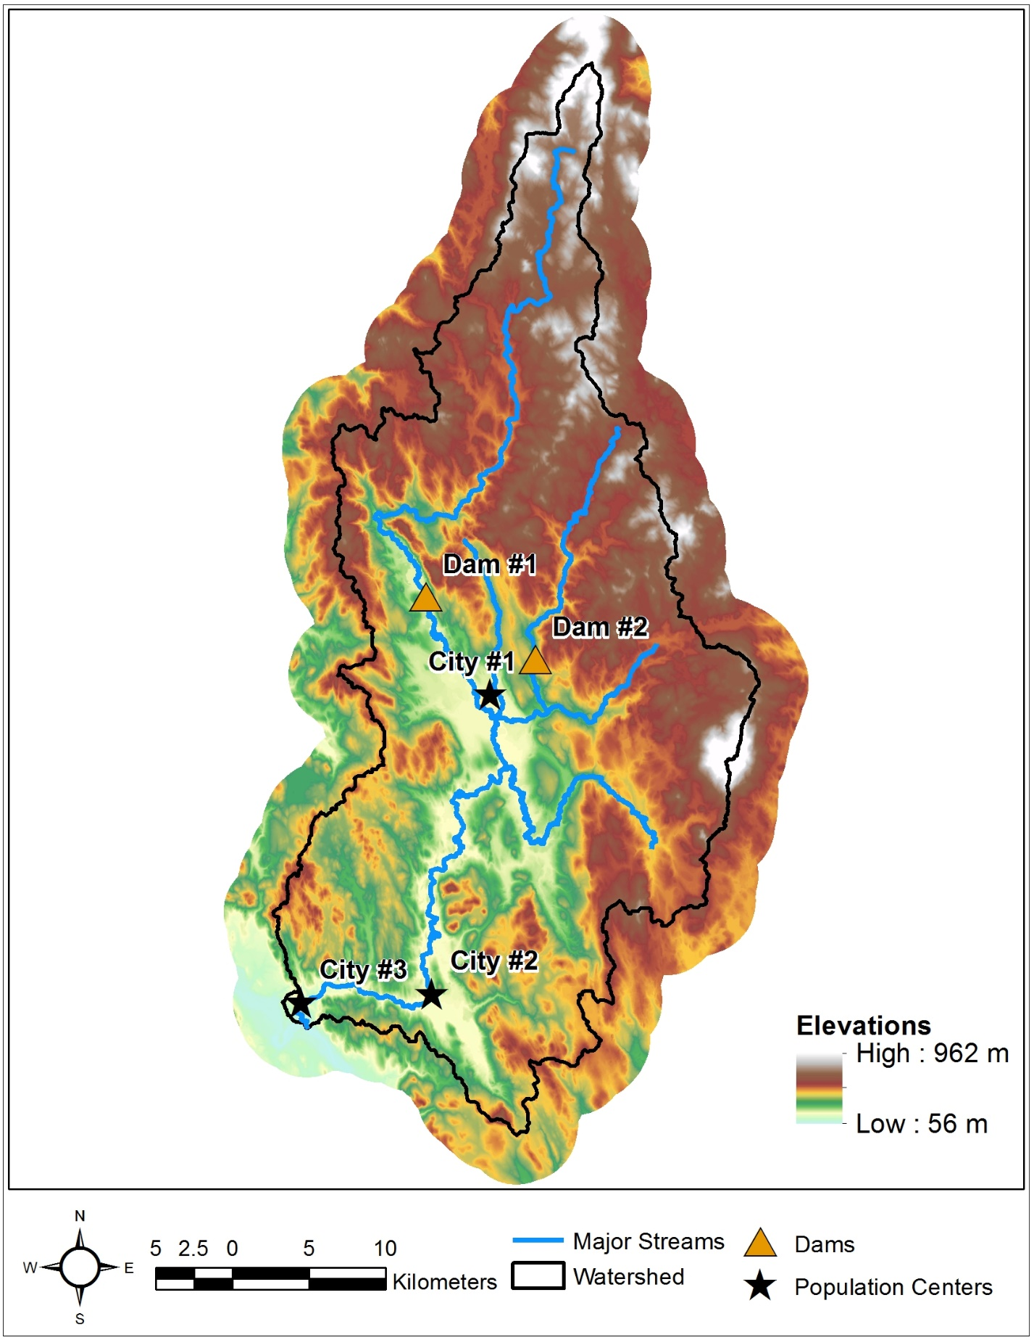
Figure 1. Watershed Overview
Data that are available for this watershed include:
- Terrain
  - Source: Shuttle Radar Topography Mission
  - Format: Raster (digital elevation model)
  - Horizontal spatial resolution: 30 meters
  - http://www.naturalearthdata.com
  - As was previously mentioned, elevations throughout the watershed range from 56 m asl to 960 m asl as shown in Figure 1.

- Land Use
  - Source: MODIS
  - Format: Raster
  - Horizontal spatial resolution: 0.5 km
  - http://landcover.usgs.gov/global_climatology.php
  - Land use classifications throughout the watershed range from forests to urban environments as shown in Figure 2.

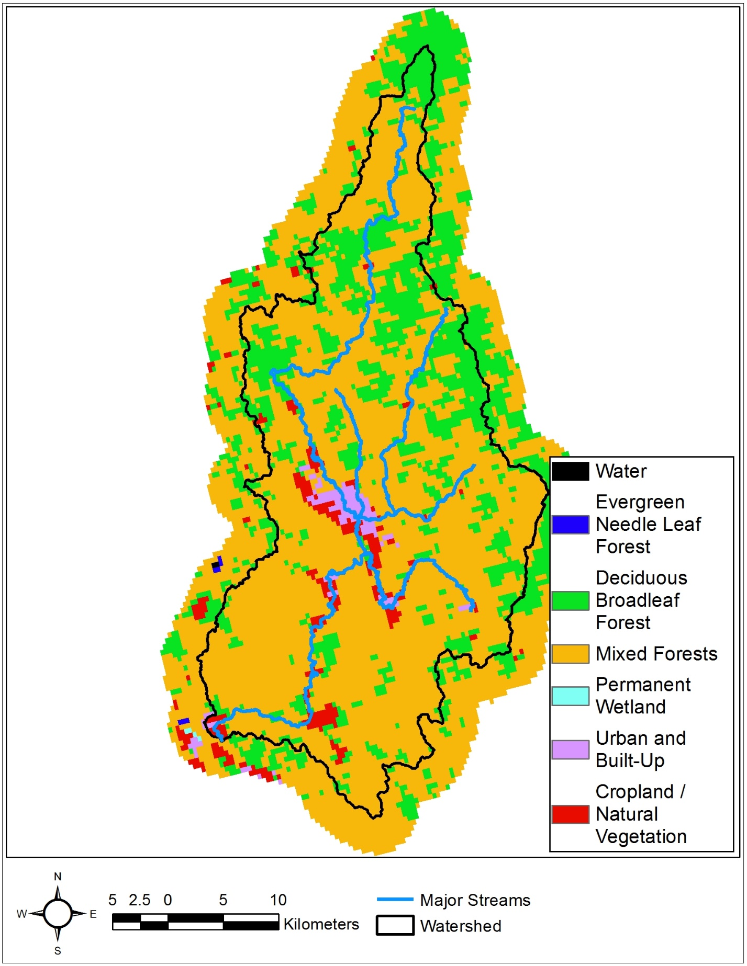
Figure 2. Land Uses
- Soils
  - Source: NRCS
  - Format: Vector
  - Horizontal spatial resolution: 1:250,000
  - https://www.nrcs.usda.gov/wps/portal/nrcs/detail/soils/survey/geo/?cid=nrcs142p2_053629
  - Surficial soil textures throughout the watershed range from sandy loam to silt loam as shown in Figure 3.

- Observed Reservoir Data
  - Number of dams: 2
  - Temporal resolution: 1 hour
  - Availability: 1960 - 2017
  - Format: Data are provided in a comma delimited format for each dam consisting of date, time, pool stage, and release rate (see sample below)
  - Pool stage units: m
  - Release units: m³/s
Date,Time,Stage,Release
10/1/2005,0:00,120.2,50.0
10/1/2005,1:00,120.5,50.0
10/1/2005,2:00,121.8,45.2
10/1/2005,3:00,123.7,40.0
10/1/2005,4:00,124.8,40.0
10/1/2005,5:00,124.6,40.0
10/1/2005,6:00,124.2,40.0

- Reservoir release policy or operating rules are:
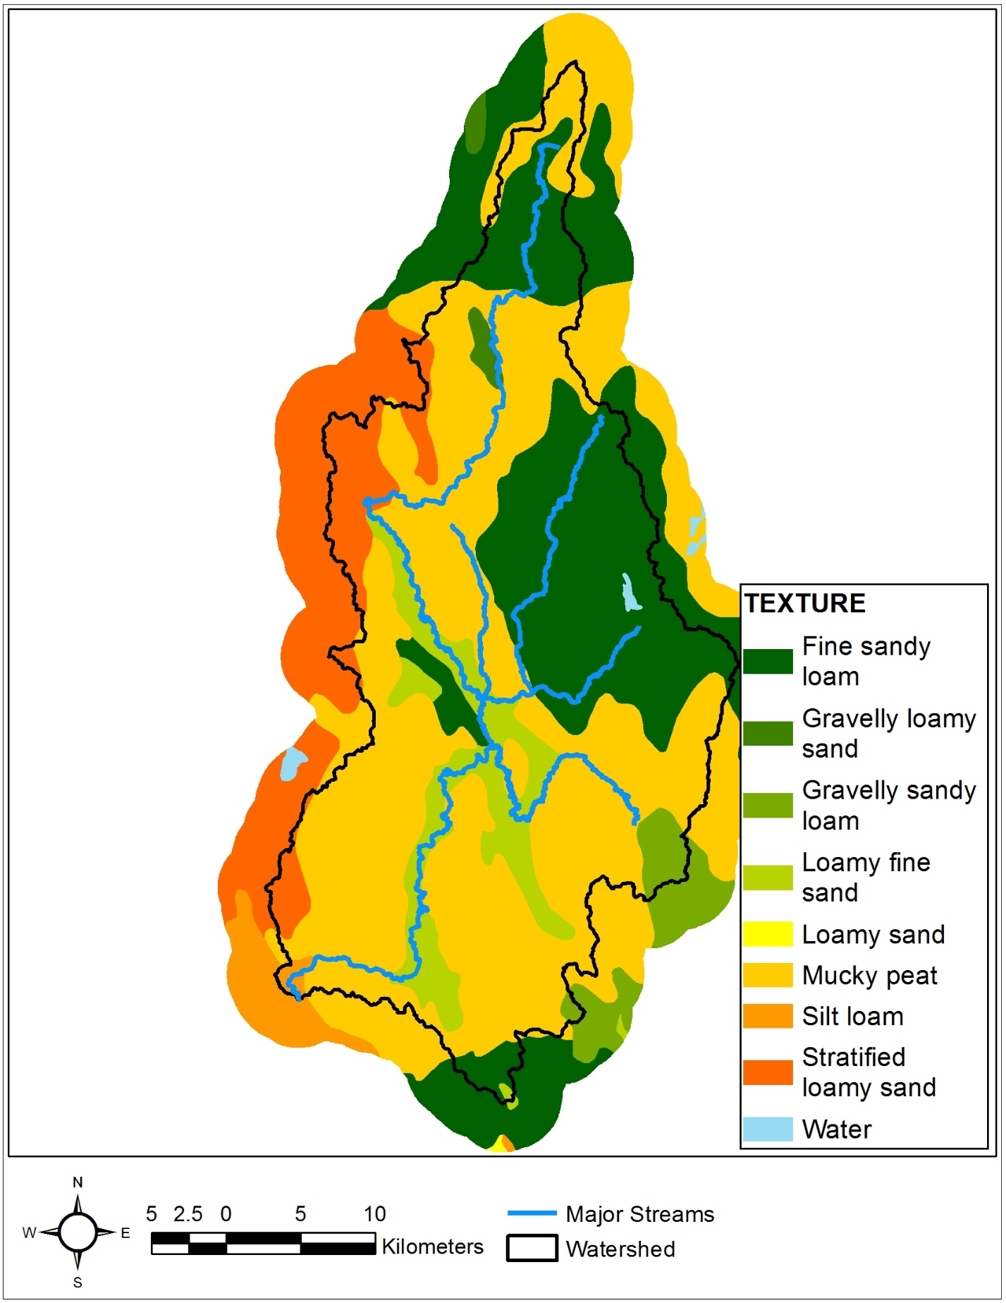
Figure 3. Soils
- Observed Streamflow
  - Number of gauges/stations: 5
  - The gauges are distributed throughout the watershed as shown in Figure 4.
  - Temporal resolution: 1 hour
  - Availability: 1985 - 2017
  - Format: Data are provided in a comma delimited format for each gage consisting of date, time, and volumetric flow rate (see sample below)
  - Units of discharge: m³/s
Date,Time,Flow
10/1/2005,0:00,10.2
10/1/2005,1:00,15.1
10/1/2005,2:00,25.8
10/1/2005,3:00,35.7
10/1/2005,4:00,42.8
10/1/2005,5:00,31.6
10/1/2005,6:00,22.2

- Observed Precipitation
  - Number of stations: 10
  - The stations are distributed throughout the watershed as shown in Figure 4.
  - Temporal resolution: 1 hour
  - Availability: 1985 - 2017
  - Format: Data is provided in a comma delimited format for each station consisting of date, time, and precipitation depth over the last hour (see sample below)
  - Units of rainfall: mm
Date,Time,Precip
10/1/2005,0:00,27.94
10/1/2005,1:00,12.70
10/1/2005,2:00,10.16
10/1/2005,3:00,0.00
10/1/2005,4:00,0.00
10/1/2005,5:00,0.00
10/1/2005,6:00,0.00
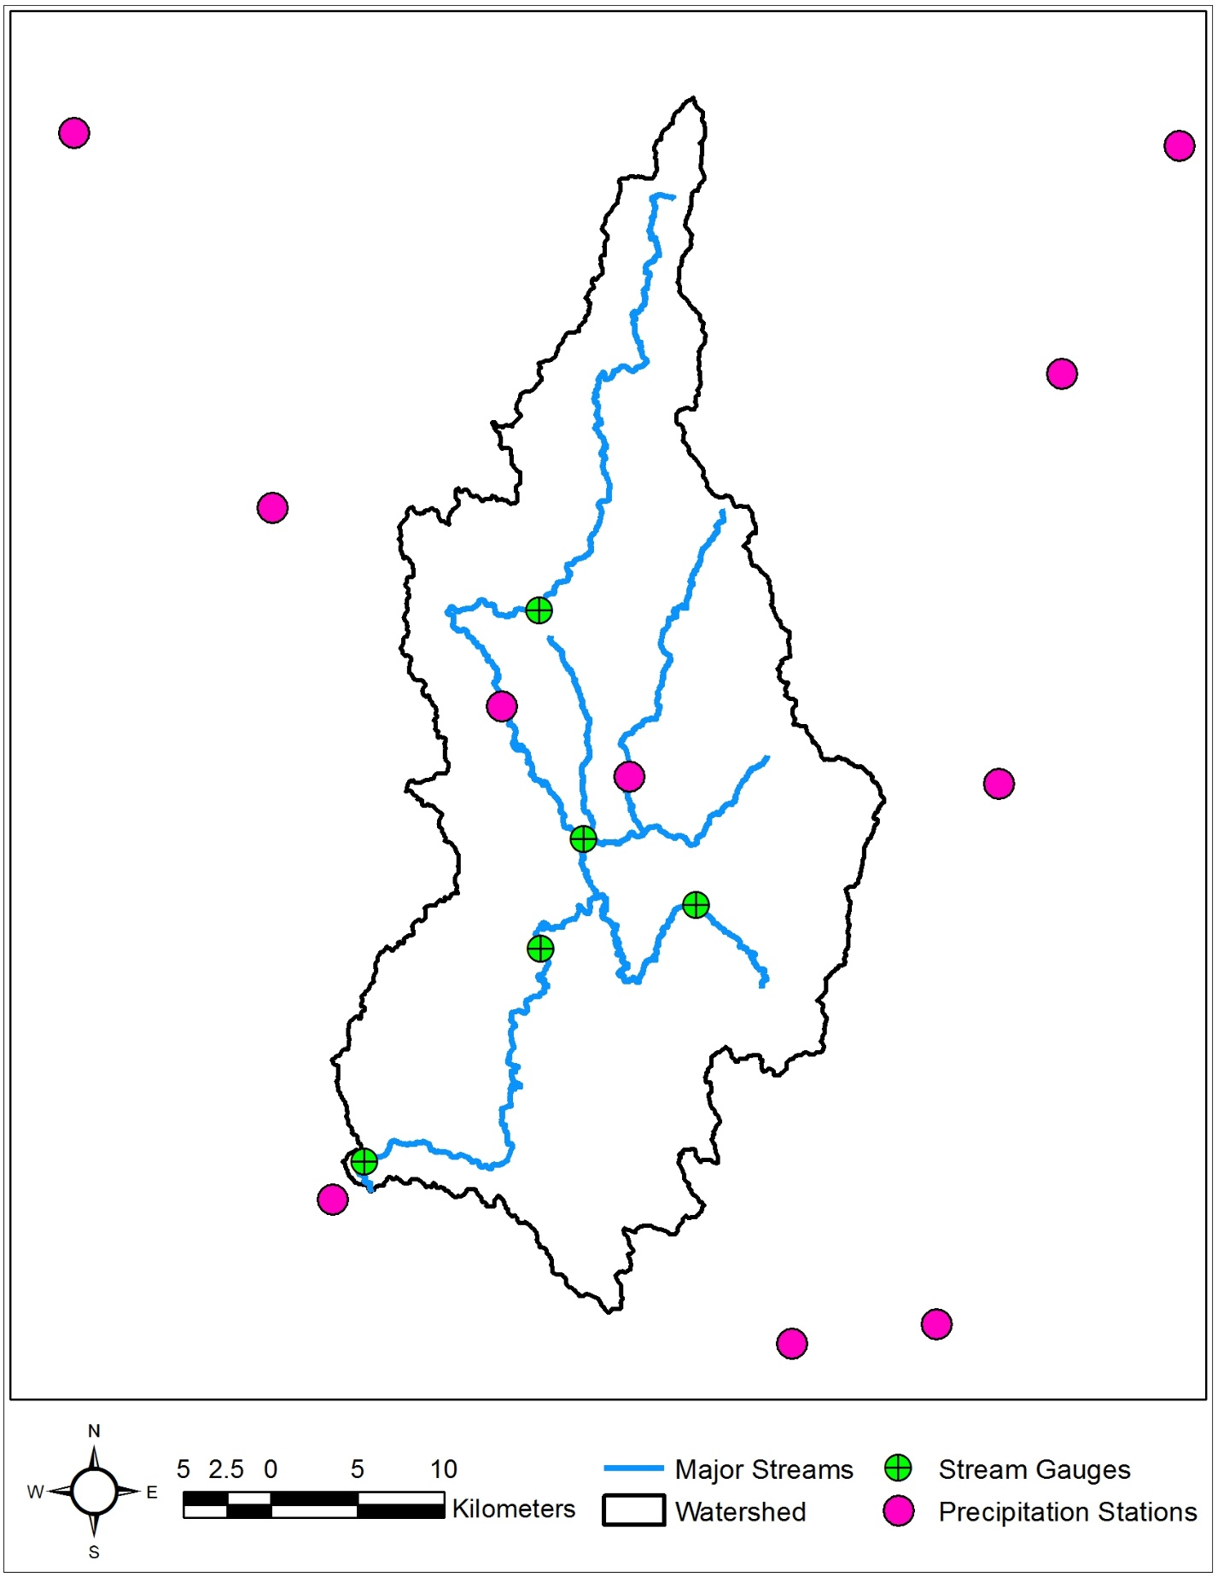
Figure 4. Stream Gauges and Precipitation Stations

