Inventory of Flood Forecasting Platforms for End-to-End End Early Warning Systems

Nilay Dogulu

Climate and Water Department
World Meteorological Organization

September 2017

Table of Contents
1. Introduction 2
2. Inventory of Flood Forecasting Platforms 2
OPERATIONAL HYDROLOGICAL FORECASTING PLATFORMS 3
2.1. DELFT-FEWS (Delft-Flood Early Warning System) 3
2.2. DEWETRA 5
2.3. DRIHM (Distributed Research Infrastructure for Hydro-Meteorology) 7
2.4. POM (Plate-forme Opérationnelle pour la Modélisation) 9
OPERATIONAL LARGE-SCALE FLOOD FORECSTING SYSTEMS 10
2.5. EFAS (European Flood Awareness System) 10
2.6. AFFS (African Flood Forecasting System) (**NOT OPERATIONAL**) 14
2.7. GLOFAS (Global Flood Awareness System) 16
2.8. GFDS (Global Flood Detection System) 20
2.9. GLOFFIS (Global Flood Forecasting Information System) 22
2.10. RASOR (Rapid Analysis and Spatialisation Of Risk) 24
DISASTER RESPONSE INITIATIVES 27
2.11. COPERNICUS EMS - MAPPING (Copernicus Emergency Management Services Mapping) 27
2.12. GDACS (Global Disaster Alert and Coordination System) 29
3. DISCUSSION 31
4. BIBLIOGRAPHY 33

Inventory of
Flood Forecasting Platforms
for End-to-End End Early Warning Systems

Introduction
This work is conducted as part of the World Meteorological Organization (WMO) Flood Forecasting Initiative (WMO-FFI) – Task 2 of the FFI Advisory Group Work Plan 2016-2019, as agreed during the first session of the Commission for Hydrology (CHy) Advisory Working Group (AWG) which was held at WMO Headquarters in Geneva, Switzerland between 27 February – 3 March, 2017.
The work plan for the focus area “Hydrological Applications, Products and Services” include the activity “(E) Implementation Strategy for the End-to-End Early Warning Systems (E2E EWS) for flood forecasting (using the Community of Practice Approach)”. One of the actions listed under this activity is “(E.2) Inventory and assessment capabilities of existing platforms and hydrological forecasting models”.
Inventory of Flood Forecasting Platforms for End-to-End End Early Warning Systems

Inventory of Flood Forecasting Platforms
The inventory on available platforms for flood forecasting and early warning presented in this report reveals clearly that the worldwide importance of flood forecasting and early warning systems have been recognized by various organisations and institutions which led several initiatives at the level of both the European Commission as well as the United Nations. Although the focus area of majority of these initiatives is continental Europe, in recent years there have been a considerable progress in extending such initiatives (mostly developed in Europe) to the global scale. However, the scope of global efforts in providing End-To-End (E2E) Flood Forecasting and Early Warning services to communities is far from being complete, and requires further consideration particularly for meeting the needs of the developing world countries. Furthermore, in line with the Sendai Framework’s global target #7 – “Substantially increase the availability of and access to multi-hazard early warning systems and disaster risk information and assessments to the people by 2030”, it is essential that E2E EWSs for flood risk management be integrated along with systems (available or to be developed) for other (hydro-meteorological and non-hydro-meteorological) hazards. In this regard, the experiences from flood forecasting could substantially guide and support further efforts in realizing this target.
Operational hydrological forecasting platforms which are included in this inventory are Delft-FEWS (Deltares, the Netherlands), DEWETRA (CIMA, Italy), DRIHM (CIMA, Italy), POM (SCHAPI, France), AFFS (EC Joint Research Centre), EFAS (EC Joint Research Centre), GLOFAS (ECMWF and EC Joint Research Centre), GFDS (EC Joint Research Centre and Darmouth Flood Observatory), GLOFFIS (Deltares, the Netherlands) and RASOR (CIMA, Deltares et al.).
There are three types of systems considered for the inventory: (1) operational hydrological forecasting platforms, (2) operational large-scale flood forecasting systems, and (3) disaster response initiatives. While the first two covers the (i) modelling & forecasting and (ii) early warning dissemination, the latter refers to (iii) decision support and (iv) response to warning, which all together, in addition with real-time data collection, constitutes the components of the End-To-End (E2E) Flood Forecasting and Early Warning.

OPERATIONAL HYDROLOGICAL FORECASTING PLATFORMS

  - DELFT-FEWS (Delft-Flood Early Warning System)
Delft-FEWS is an open data handling platform which binds datafeeds and models together in an operational forecasting and early warning system. It has been applied in many operational forecasting centres all over the world. Providing a platform that offers flexibility in the integration of models and data, Delft-FEWS has contributed to changing the paradigm of flood forecasting systems from a model centric approach to a data centric approach.
Website: http://oss.deltares.nl/web/delft-fews/
Developers: Deltares, the Netherlands
Download: http://oss.deltares.nl/web/delft-fews/download
Registration required: Free licence for end-users
Contact: FEWS-PM@deltares.nl
Technical features: Delft-FEWS is an open data handling platform initially developed as a hydrological forecasting and warning system. Essentially it is a sophisticated collection of modules designed for building a hydrological forecasting system customised to the specific requirements of an individual organisation. Because of its unique characteristics concerning data importing and processing and model connections, Delft-FEWS has also been applied in a wide range of different operational situations. Examples are water quality forecasting, reservoir management, operational sewer management optimization, and even peat fire prediction.
Delft-FEWS provides an open shell system for managing forecasting processes and/or handling time series data. Delft-FEWS incorporates a wide range of general data handling utilities (e.g. data verification, imputation of missing values, and pre-processing of meteorological data), while providing an open interface to any external (forecasting model). The modular and highly configurable nature of Delft-FEWS allows it to be used effectively for data storage and retrieval tasks, simple forecasting systems and in highly complex systems utilising a full range of modelling techniques. Delft-FEWS can either be deployed in a stand-alone, manually driven environment, or in a fully automated distributed client-server environment.
The Delft-FEWS system contains no inherent hydrological modelling capabilities within its code base. Instead it relies entirely on the integration of (third party) modelling components. The objective of the system is not to provide forecasting capabilities in the form of hydrological modelling algorithms, but rather to provide the platform through which model codes can be brought to the operational domain (Werner et al., 2013).
The main philosophy underlying the system is to provide an open shell tool, that allows integration of arbitrary hydrological and river routing models with meteorological data and numerical weather forecasts. In its actual form DELFT-FEWS constitutes a collection of platform-independent software modules, linked to a central database. The database is used to store historical runoff data from gauging stations, and meteorological data from local and synoptic meteorological stations. These can be updated on-line through direct access to national weather services, weather forecast centres and hydro-meteorological services (Reggiani et al., 2013).
Delft-FEWS offers many options for the user to interact with the system. For a modern operational (forecasting) system this interaction is crucial. In water management, and other sectors, different types of models are being used to simulate real-world processes. Delft-FEWS is capable to connect to many of these models, and new connections can be made easily.
Two times a year a new version of Delft-FEWS is released, containing new features and bug fixes. Despite not being open source, Delft-FEWS can be configured easily to satisfy individual needs of the users. Some parts of Delft-FEWS will become open source in the next few years.
Applications: Since its introduction in 2002/2003, the current generation of the Delft-FEWS operational forecasting platform has found application in over forty operational centres. In these it is used to link data and models in real time, producing forecasts on a daily basis. In some cases it forms a building block of a country-wide national forecasting system using distributed client-server technology. In other cases it is applied at a much smaller scale on a simple desktop workstation, providing forecasts for a single basin. The flexibility of the software in open integration of models and data has facilitated several research efforts in hydro-meteorological forecasting. (Werner et al., 2013)
Delft-FEWS has been applied as the primary operational flood forecasting tool used by flood management authorities in basins across the continental United States and Alaska, in England and Wales, Scotland, Ireland, Netherlands, Germany, Austria, Spain, Italy, Switzerland, Taiwan, Pakistan, the Zambezi basin, Ghana, Canada, Colombia, Indonesia, Bolivia and by the Mekong River Commission. Delft FEWS is currently also being applied more and more in coastal areas in for example the Netherlands and Brazil. Furthermore, Delft-FEWS has proven to be an effective tool for supporting the operational management of hydropower facilities in Austria, Uruguay/Argentina and the United States of America.
In addition to its role as a flood forecasting tool, Delft-FEWS has also be extended for use as a water quality forecasting tool in Netherlands, Singapore and South-Korea; as a groundwater scenario management tool in the National Groundwater Modelling System in England and Wales; as a drought forecasting system in River Po, Italy; and Taiwan and as a Water Information System for a number of Water Boards in The Netherlands.
User’s assistance: Deltares supports interested parties in the implementation of their operational water management system with a team of water experts, software developers and ICT experts. Deltares offers a range of support and maintenance services related to the Delft-FEWS software. Depending on the responsible organization and the particular requirements for the operational (forecasting / water management) system, the support and maintenance requirements may differ significantly.
Additional information: Delft-FEWS supports the following languages: English, Dutch, German, Spanish, Chinese, Indonesian.
Documentation (i.e. user’s manual, quick start guide): There are various sources of documentation in the form webinars, questions-answers, examples of demonstrations of common tasks, problems-solutions, videos, etc. all of which are available through http://oss.deltares.nl/web/delft-fews/get-help and https://publicwiki.deltares.nl/display/FEWSDOC. A forum and support area is also available through the websites, http://oss.deltares.nl/web/delft-fews/forum and https://publicwiki.deltares.nl/display/FEWSDOC/Support+Area, respectively.
- http://oss.deltares.nl/web/delft-fews/documents
- http://oss.deltares.nl/web/delft-fews/webinars
- https://publicwiki.deltares.nl/display/FEWSDOC/Documentation+Area
References:
- https://www.deltares.nl/en/software/flood-forecasting-system-delft-fews-2/
- http://oss.deltares.nl/web/delft-fews/home
- Werner, M., Schellekens, J., Gijsbers, P., van Dijk, M., van den Akker, O., & Heynert, K. (2013). The Delft-FEWS flow forecasting system. Environmental Modelling & Software, 40, 65-77. http://www.sciencedirect.com/science/article/pii/S1364815212002083
- Reggiani, P., Kwadijk, J. C. J., Werner, M. G. F., van Dijk, M. J., Schellekens, J., van Kappel, R. R., & Sprokkereef, E. (2003, April). DELFT FEWS: an open shell flood forecasting platform. In EGS-AGU-EUG Joint Assembly, Abstract #3494, Nice, France, 6 - 11 April. http://adsabs.harvard.edu/abs/2003EAEJA.....3494R

  - DEWETRA
DEWETRA is an operational system for integrated management of hydro- meteorological information for disaster risk reduction. DEWETRA is an IT system aimed at weather-related risk forecasting and monitoring.
Website: http://www.cimafoundation.org/en/cima-foundation/dewetra/
Developers: CIMA Research Foundation – International Centre for Environmental Monitoring, Italy
Download: Not applicable
Registration required: Available to WMO members, upon their request
Contact: lauro.rossi@cimafoundation.org
Technical features: The DEWETRA platform is a real-time integrated system for hydro-meteorological and wildfire risk forecasting, monitoring and prevention. DEWETRA collects and systematizes all data, automatically or manually recorded, and produces value-added elaborations: forecast models, remote and in situ observations are integrated with vulnerability and exposure data to produce risk scenarios in real time. The system allows end users to build impact scenario of the forecasted event by crossing real-time information on hazard, exposure and vulnerability.
DEWETRA is based on the rapid availability of various types of information, such as observed and forecasted data related to risk (hazard maps, hydro-meteorological data in real time, remote sensing, user data, land cover, land use, vegetation, etc.). Integration of different types of data relevant to risk management improves speed, effectiveness and accuracy of decisions, and helps establishing up-to-date and reliable risk scenarios. Hence, the value of available information and the level of knowledge of forecasters and disaster managers increases significantly.
The DEWETRA platform architecture is based on a three-layer software (“three-tier architecture”) distributed on multiple servers: a strong middle-ware ensure robustness and computational load balancing, whereas a Web-GIS interface facilitate the information distribution. Different sources of information are ingested and managed within the platform, taking into account their diverse space-time scales and degrees of uncertainty and reliability. Different modules aimed at forecasting specific hazards such as fires, landslides and floods, can be easily integrated into the platform.
Data provision, based on Open Geospatial Consortium (OGC) Web Services standards (WMS, WCS, WFS, WPS), allows distributed configurations where information is published to the systems directly at their source, reducing data transfer. OGC compliancy ensures interoperability with external interfaces of publication, without the obligation to physically import the data in DEWETRA database.
DEWETRA uses a hybrid architecture which combines an integrated server for the back-up of data collected locally and web applications that allow a capillary distribution of the information. The software provides, through a graphic interface, high-resolution information continuously updated, allowing the user to track weather events, build detailed risk scenarios and evaluate phenomena potential impact on communities and infrastructures.
DEWETRA allows any computer connected to internet to use, in geographic modality, the system data independently from the source. In fact, the software manages both the data used by the platform of Functional Centre National System and the territorial and geospatial ones, published as WMS service - Web Map Service- by other platforms. DEWETRA is able to upload and visualize geo-referenced layers both static and dynamic, allows to view results of each measurement station and other observation tools more advances and offers interactive tools and functionalities to the usee to the analysis of ongoing or past events. Due to the high-frequency and diffusion of the phenomena, for now, DEWETRA is applied to prioritary events such as fires and flooding.
Applications: The DEWETRA platform has been designed and developed by CIMA Research Foundation, for the Italian of Civil Protection Department. The platform is currently used at national level by forecasters and disaster managing authorities in 13 countries: Italy, Bolivia, Ecuador, Serbia, Croatia, Albania, Lebanon, China and Philippines. DEWETRA is fully operational at the Italian Prime Minister Office – National Department for Civil Protection – “Centro Funzionale Centrale”. In the Caribbean, the platform is being used at the regional level, shared among different countries and coordinated by the Caribbean Institute for Meteorology and Hydrology (CIMH). Columbia, Guyana, Fiji requested have recently sent requests for its implementation.
Flood-PROOFS (Flood-PRObabilistic Operational Forecasting System) is a system designed to assist decision makers during the operational phases of flood forecasting, nowcasting, mitigation and monitoring in small and medium catchments (areas of the order of some 10³ km²), typical of Mediterranean and Alpine environment.
User’s assistance: Training sessions and manuals are available to the end user. Remote and onsite assistance is to be provided by the staff of the Civil Protection Department and national competence centres. Organization of workshops is also possible.
Additional information: The DEWETRA platform is offered as an Open-Source tool to the WMO affiliated countries as an Italian contribution to the WMO programs on flood management and forecasting (FFI and APFM). The initiative was launched by the Italian delegation participating to the 14th WMO Commission for Hydrology (CHy-14) in November 2012. The five-year agreement defines the conditions for the transfer, installation and configuration of DEWETRA in countries requesting it through WMO. The software is then made available through an open source license agreement.
DEWETRA web platform is available only in English and Italian languages.
Documentation (i.e. user’s manual, quick start guide):
-
References:
- http://www.cimafoundation.org/en/cima-foundation/dewetra/
- http://ipafloods.mydewetra.org/
- http://www.protezionecivile.gov.it/jcms/en/schede_tecniche.wp;jsessionid=D56B91C4D15E61B31F5AF65539E63712?contentId=SCT26266
- http://www.cimafoundation.org/en/signed-international-memorandum-of-understanding-for-the-promotion-of-dewetra-platform/
- https://public.wmo.int/en/media/news/wmo-and-italian-national-civil-protection-department-agreement

  - DRIHM (Distributed Research Infrastructure for Hydro-Meteorology)
DRIHM provides a web-based portal for hydro-meteorological research on high impact weather events. DRIHM, or the Distributed Research Infrastructure for Hydro-Meteorology, together with its US facing companion project (2011-2015), DRIHM2US (2012-2015), both funded by the European Union, have developed a prototype research infrastructure for simulating the complete process involved in extreme hydro-meteorological events such as flash flooding. This prototype e-Science environment provides advanced end-to-end services (models, datasets and post-processing tools), with the aim of paving the way to a step change in how scientists can approach studying these events, with a special focus on flood events in complex topography areas (Parodi et al., 2017).
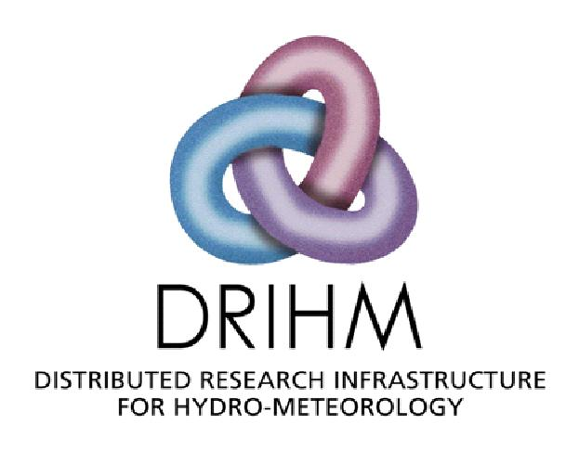 | Website: http://www.drihm.eu/  Developers: CIMA Research Foundation (CIMA, Italy), Ludwig-Maximilians-Universitat Munich (LMU, Germany), Institute for Atmospheric Physics (DLR,Germany), Institute of Applied Mathematics and Information Technology (CNR-IMATI, Italy), Technical University of Madrid (UPM, Spain), Centre National de la Recherche Scientifique (CNRS, France), Republic Hydrometeorological Service of Serbia (RHMSS, Serbia), Stichting Deltares (DELTARES, the Netherlands), HR Wallingford Limited (HRW, UK), Consortium of Universities for the Advancement of Hydrologic Science Inc. (CUAHSI)  Download: Not applicable  Registration required: Yes  Contact: antonio.parodi@cimafoundation.org
Technical features: DRIHM provides an open, fully integrated workflow platform for predicting, managing and mitigating the risks related to extreme weather phenomena, with special focus on flood and flash flood events. Designed by the collaborative efforts of both ICT and hydro-meteorological scientific communities, DRIHM is an easy-to-use e-Science environment that enables model execution as a service as well as the creation of (arbitrary) model chains. Both functionalities enables the modelling, definition, and execution of a probabilistic forecasting chain on an existing e-Infrastructure. From an ICT operational perspective, the major objective of DRIHM is to support users in enabling the hydro-meteorological research community to setup chains of models on various spatio-temporal scales, to support their integrated configuration, to fetch the data, and to execute the workflow on the most appropriate ICT resources. The functionality of the DRIHM Distributed Computing Infrastructure (DDCI) is expressed as a set of Application Services, that is, applications that you can use to perform experiments. The scope of these services are:
- Running a collection of meteorological models to simulate weather conditions and save the results of these simulations in files with standard formats.
- Running a collection of hydrological models (i.e. HBV, DRIFt, RIBS) to assess how river catchments drain.
- Running a composition of hydraulic and impact models to assess river channel flow, overtopping and the damage caused by the resultant flood. This composition has been set up and calibrated for important use cases.
- Running combinations of the meteorological, hydrological and hydraulic models in model chains. The portal guides you through setting up these experiments and, in particular, the connections between the models.
- Saving result files in your own repository for sharing with other users.
- Visualizing standard results files with built-in utilities and other standard desktop tools.
The model structure and interfaces can be seen in the Figure X.3. The present version of the platform offers nine models:
- three meteorological models: WRF (Weather Research and Forecasting)-ARW (Advanced Research WRF), WRF-NMM (Nonhydrostatic Mesoscale Model) and Meso-NH, together with the option for stochastic downscaling with RainFARM.
- three hydrological models to simulate catchment drainage: the semi-distributed rainfall runoff model DRiFt (Discharge River Forecast), the distributed rainfall-runoff model RIBS (Real-time Interactive Basin Simulator) and the distributed hydrological model HBV (Hydrologiska Byråns Vattenbalansavdelning), together with the option to initialize the models by using rain gauge observations.
- two hydraulic model options to simulate the flood itself: (i) an Open Modelling Interface (OpenMI) consisting of three models (MASCARET, RFSM and Impact Calculator (or Property Damage)) to model lateral exchanges between a river channel and a floodplain, (ii) Delft3D.
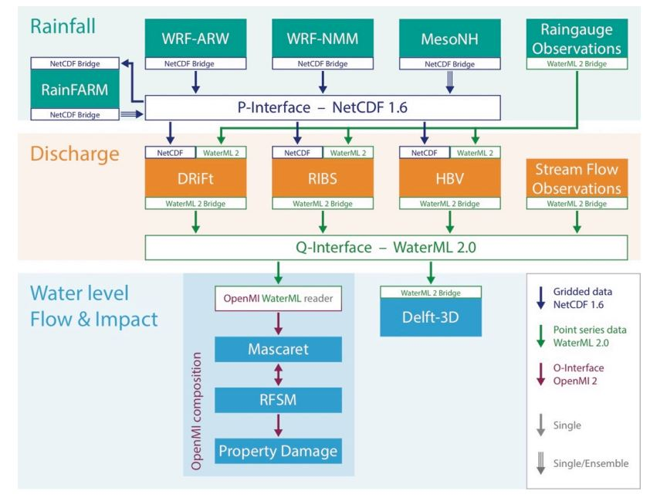
Figure X.3 DRIHM model structure and interfaces
Although other hydrological and hydraulic models could be introduced in the platform, the present configuration allows realizing 3x3x2 (18) different hydro-meteorological chains. Both meteorological and hydrological models have been selected for their specific ability to reproduce mesoscale deep moist convective processes and their hydrological effects in areas where complex topography plays crucial role. However, DRIHM portal can be extended at the model level by inclusion of new hydro-meteorological model engines and also across new model domains.
Applications: Three user categories exist for the DRIHM portal: citizen scientists, scientists and expert scientists. By integrating hydro-meteorological research resources, DRIHM allows specialists to enter the e-Science environments more easily and at the same time stimulate use by non-specialists. The portal supports users in experiment configuration and execution by providing integrated solutions to manage and exploit the e-Infrastructure’s key ingredients: state-of-the-art numerical simulation model engines, a set of powerful distributed ICT resources and an easy-to-use interface. The result is a flexible and extensible environment.
User’s assistance: All DRIHM users are offered with a rich set of training information to learn more about available modelling and visualization services.
Additional information: CIMA Research Foundation (CIMA, coordinator), Ludwig-Maximilians-Universitat Munich (LMU), Institute for Atmospheric Physics (DLR), Institute of Applied Mathematics and Information Technology (CNR-IMATI), Polytechnic University of Madrid (UPM), Centre National de la Recherche Scientifique (CNRS), Deltares, HR Wallingford Limited (HRW), Consortium of Universities for the Advancement of Hydrologic Science Inc. (CUAHSI).
Documentation (i.e. user’s manual, quick start guide): In the DRIHM website there is a “Support Centre” (http://www.drihm.eu/index.php/support) that offers a user forum and various training materials as well as advanced documentation on DRIHM structure and its system components. The DRIHM Forum is a forum dedicated to the interactions among people interested in hydro-meteorological research: the DRIHM users, citizen scientists and project partners. Web pages explaining how to perform various tasks and listing most frequently asked questions with their answers (How-To and FAQs) are also available.
References:
- http://www.drihm.eu/
- Parodi, A., Kranzlmueller, D., Clematis, A., Danovaro, E., Galizia, A., Garrote, L., ... & Siccardi, F. (2017). DRIHM (2US): an e-Science environment for hydro-meteorological research on high impact weather events. Bulletin of the American Meteorological Society, (2017, in press). DOI: 10.1175/BAMS-D-16-0279.1. http://journals.ametsoc.org/doi/abs/10.1175/BAMS-D-16-0279.1

  - POM (Plate-forme Opérationnelle pour la Modélisation)
At national level, the French rainfall-flood vigilance system is a notable example of inter-institutional coordination aimed at countrywide multi-hazard early warning system. Meteorological vigilance maps for the following 24 h are issued twice daily by Meteo-France, covering different types of weather extremes and recently including coastal floods. In addition, flood vigilance maps are published online by the Ministry of Sustainable Development through the collection of information from the several departments by the national forecasting center SCHAPI. (Alfieri et al., 2012)
Website:
Developers:
Download: Not applicable
Registration required: Yes
Contact:
Technical features: …
Applications: …
User’s assistance: …
Additional information: …
Documentation (i.e. user’s manual, quick start guide): …
References:
- http://www.vigicrues.gouv.fr/

OPERATIONAL LARGE-SCALE FLOOD FORECSTING SYSTEMS

  - EFAS (European Flood Awareness System)
The European Flood Awareness System is a European Commission initiative aimed at increasing preparedness for floods in trans-national European river basins by providing local water authorities with medium-range and probabilistic flood forecasting information 3 to 10 days in advance. At the continental scale, EFAS is run by the Joint Research Centre of the European Commission pre-operationally.
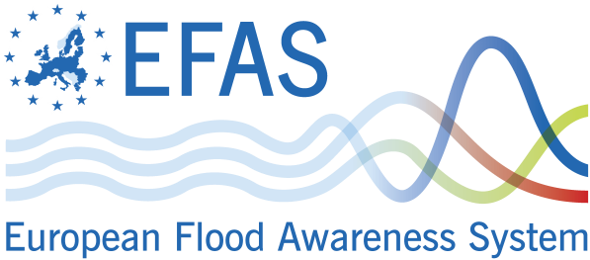 | Website: https://www.efas.eu/  Developers: EC Joint Research Centre  Download: Not applicable  Registration required: EFAS is free and accessible for EU & non EU countries  Contact: info@efas.eu
Technical features: EFAS is the first operational pan-European system for the monitoring and forecasting of floods. It provides a variety of complementary, added value flood early warning information up to 10 days in advance to its partners: the regional and national hydrological services as well as the European Commission’s Emergency Response and Coordination Centre (ERCC). EFAS is built on the interplay of four centers, operated by different consortia of service providers:
- The EFAS Hydrological Data Collection Centre collects historical and real-time data on discharge (the amount of water flowing through a river channel) and water level of rivers across Europe.
- The EFAS Meteorological Data Collection Centre collects historic and real-time meteorological data across Europe. It has been designed to collect and to validate meteorological observations, to produce a European grid of 5 km by 5 km of essential variables on a 6-hourly basis and to make it available for downstream usage as input to the forecast systems.
- The EFAS Computational Centre executes forecasts and hosts the EFAS web platform.
- The EFAS Dissemination Centre summarizes key information on a daily basis and disseminates it to the partners and the ERCC.
Weather forecasts EFAS uses multiple weather forecasts and ensemble prediction system (EPS) as input as input to the distributed hydrological model LISFLOOD. Its forecasts are based on two deterministic, medium-range forecasts from the European Centre for Medium-Range Weather Forecasts (ECMWF) and the German Weather Service (DWD), (and thus different models) and on two sets of EPS: One from ECMWF which covers the medium-range up to 15 days globally (with a spatial resolution of ~30 km and 51 members, and one from the Consortium for Small-scale Modeling (COSMO), a limited area model EPS covering most of Europe with a shorter range up to 5 days (with a spatial resolution of 7 km and 16 members). The reason for using the shorter term EPS is to enhance the spread of EPS within the first few days and to have a finer grid information in particular for mountainous areas. This allows to better identify the location of the floods within the river basin.
Hydrological (and hydraulic) modelling The hydrological model used for EFAS is LISFLOOD. It is a hybrid between a conceptual and a physical rainfall-runoff model combined with a routing module in the river channel. LISFLOOD has been specifically designed for large river catchments. The precipitation, temperature, and evaporation from each of the four forecasts are used as input to the LISFLOOD, which is used as both the rainfall-runoff modelling and the flow routing. In particular, it makes use of data layers that are available for the JRC at European scale, such as land use, soil type and texture, river network. These features make the model particularly suited for EFAS and supported its implementation in the forecasting system. LISFLOOD simulates canopy, surface and surface processes such as snowmelt (including accounting for accelerated snowmelt during rainfall) and preferential (macropore) flow, soil and groundwater system processes and flow in the river channel.
Flood warning Simulated ensemble hydrographs are produced by LISFLOOD; however, these alone do not constitute a flood forecast. A decision-making element needs to be incorporated. EFAS is providing information to the national hydrological services only when there is a danger that critical flood levels might be exceeded. In EFAS, the critical thresholds are needed at every grid point and therefore cannot be derived from observations. Instead, based on observed meteorological data, long term discharge time series are calculated at each grid with the same LISFLOOD model parameterisation that is set up in the forecasting system. From these long-term simulations return periods are estimated – currently the 1, 2, 5 and 20-year return periods. All flood forecasts are compared against these thresholds – at every pixel – and the threshold exceedance calculated. Only when critical thresholds are exceeded persistently over several forecasts, information at these locations is produced, e.g. in the form of colour-coded overview maps or time series information at control points. The persistence criteria has been introduced to reduce the number of false alarms and focus on large fluvial floods caused mainly by widespread severe precipitation, combined rainfall with snow-melting or prolonged rainfalls of medium intensity.
Forecast verification For EFAS two types of verifications are applied. The first one is event-based – for each flood alert the hit, false alarm and misses are assessed through feedback reports and news media. If a flood alert has been sent but no flooding was observed, a false alarm is counted. If somewhere in the basin flooding has been report, a hit is counted. If flooding has been reported for which an alert was not sent (even if the system itself simulated an event), a missed event is counted. The events are assessed through feedback reports and media throughout the year and reported during the EFAS annual meeting. In addition to the event-based verification, also skill scores are computed including Brier Skill Score, Root Mean Square Error, Nash Sutcliffe efficiency, continuous rank probability score, etc. These are reported regularly in the EFAS bulletins and in publications.
Forecast Visualisation Alongside warnings for each forecast point, the EFAS interface (e.g. Figure 3) provides ensemble hydrographs, which allow the interpretation of the spread of the ensemble and the uncertainty in the forecast. Persistence diagrams showing information about the previous four forecasts also give the user additional information on the forecast uncertainty as NWP models should be able to pick up large-scale synoptic weather systems that typically produce severe events in advance, therefore showing a flood risk consistently in each forecast run.42 The EFAS interface provides a map of Europe, with all points forecasting a flood event designated by a color responding to the warning threshold; this allows an overview of forecast flood events across the continent. The information and visualization within EFAS are designed to give clear, concise, and unambiguous early warning results.
Warning Dissemination Copernicus is the European Emergency Management Service, and EFAS is the operational flood early warning system designed to disseminate warnings for Europe under the Copernicus initiative. According to the WMO Executive Council (EC-LVII-Annex VII),43 National Meteorological and Hydrological Services (NMHS) constitute the single authoritative voice on weather warnings in their respective countries. Therefore, in order to respect the single voice principle with regard to floods, EFAS real-time information is provided only to hydro-meteorological authorities signing a ‘Condition of Access’ document. EFAS sends warning emails to these national authorities responsible for flood forecasting, designed to bring awareness of an upcoming flood event, with further details accessed through the interface. There are four types of warning emails provided. Flood Alerts are issued when a river basin has a probability of exceeding critical flood thresholds more than 2 days ahead; Flood Watches are issued when there is a probability of a river basin exceeding critical thresholds, but the event does not satisfy the conditions for a Flood Alert (such as river basin size or warning lead time); and Flash Flood Watches are issued when there is a >60% probability of exceeding the flash flood high alert threshold. An example of an EFAS Flood Alert is given in Box 1. The 2-day lead time criteria is specified as the forecasting systems used by the national authorities have usually issued a national warning with a lead time of up to 2 days. Additionally, daily overviews are sent to the Emergency Response Coordination Centre (ERCC) of the EC, containing information on ongoing floods in Europe, as reported by the national services and EFAS warnings.
The schematic overview of EFAS is provided in Figure X.6.
Applications: EFAS is integrated in the daily forecasting procedures of many national hydrological services across Europe, providing operational early warnings and additional information that is used for decision-making purposes at national and local scales. Additionally, EFAS is used by the Emergency Response Coordination Centre (ERCC) to compile reports on the flood situation and outlook and for the coordination of emergency response at the continental scale.
The transferability of the EFAS methods to other climatic regions and flood types has been extensively and successfully tested by Alfieri et al. (2012b, 2013) and Thiemig et al. (2010)(Thiemig et al., 2015). Alfieri et al. (2012b) has shown promising results in the adaptation of EFAS for small scale catchments and flash flood early warning, through the use of a long-term reforecast dataset for deriving coherent warning thresholds at the small scale (Alfieri et al., 2012a).
The EFAS and its global equivalent (GloFAS) are nearly completely automated and are intended to serve global disaster relief organizations and the operational agencies of countries with transboundary basins and/or relatively underdeveloped medium-range river forecasting systems (Alfieri et al. 2013, as cited in Pagano et al., 2014).
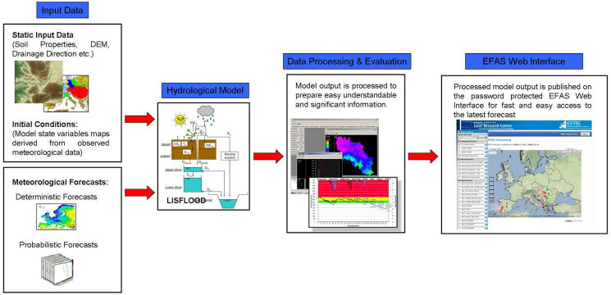
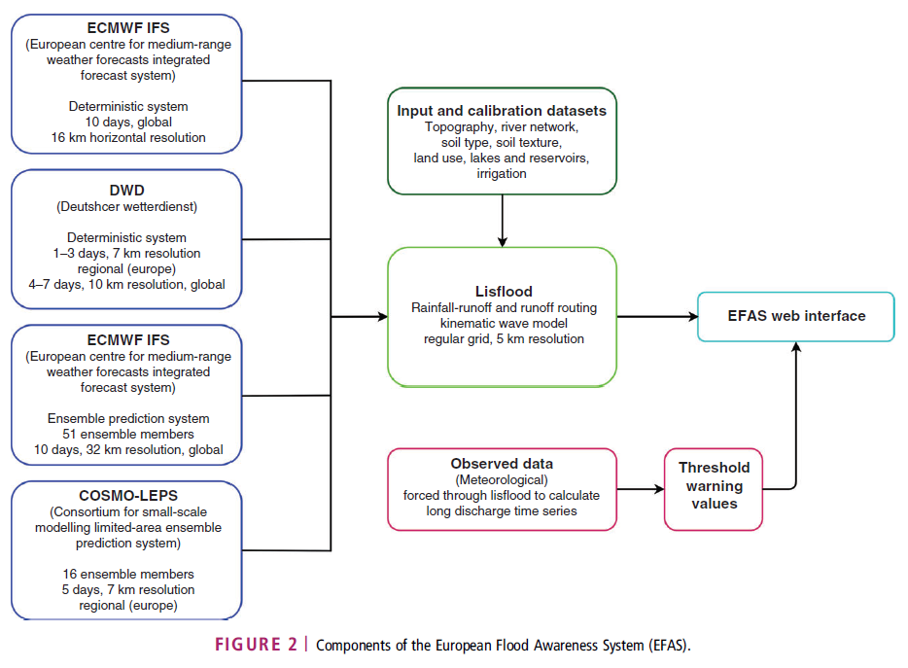
Figure X.6 Schematic overview of EFAS. Source: https://www.efas.eu/about-efas.html (top), Emmerton et al. (2016) (bottom).
User’s assistance: There are various videos available on the EFAS website.
Additional information: From 2005 to 2010 EFAS was tested in real-time mode, first with the National hydrological services and later also with the European Civil Protection. In 2011 EFAS became part of the Emergency Management Service of the COPERNICUS Initial Operations and in support to European Civil Protection. The operational components have been outsourced to Member State organisations. EFAS is running fully operational since autumn 2012.
Every national, regional or local authority involved in flood forecasting within its country can become an EFAS partner. EFAS forecasts are provided for free and are not limited to EU Member States.
The EFAS network consists of National Hydrological services and associated partners. Associated partners can be Civil Protection authorities which are associated to their National or Regional Hydrological Service. In 2013 EFAS counts 33 partners and several authorities under negotiation. International Commission for the Protection of the River Danube (ICPDR). EFAS has been adopted as part of the Danube Flood Action Plan and had developed a stand-alone EFAS-Danube system. However, with the development of the EFAS information system, a dedicated EFAS Danube system became obsolete and has been fully integrated in the operational EFAS-IS. EFAS experts report regularly to ICPDR.
Documentation (i.e. user’s manual, quick start guide): There are various introductory video tutorials available on the EFAS website (https://www.efas.eu/efas-videos.html). Annual partner meetings are held regularly.
References:
- https://www.efas.eu/
- Ramos, M. H., Bartholmes, J., & Thielen‐del Pozo, J. (2007). Development of decision support products based on ensemble forecasts in the European flood alert system. Atmospheric Science Letters, 8(4), 113-119. DOI : 10.1002/asl.161. http://onlinelibrary.wiley.com/doi/10.1002/asl.161/full
- Thielen, J., Bartholmes, J., Ramos, M. H., & Roo, A. D. (2009). The European flood alert system–Part 1: concept and development. Hydrology and Earth System Sciences, 13(2), 125-140. DOI: 10.5194/hess-13-125-2009. https://www.hydrol-earth-syst-sci.net/13/125/2009/hess-13-125-2009.html
- Bartholmes, J. C., Thielen, J., Ramos, M. H., & Gentilini, S. (2009). The european flood alert system EFAS–Part 2: Statistical skill assessment of probabilistic and deterministic operational forecasts. Hydrology and Earth System Sciences, 13(2), 141-153. DOI: 10.5194/hess-13-141-2009. https://www.hydrol-earth-syst-sci.net/13/141/2009/hess-13-141-2009.html
- Pappenberger, F., Thielen, J., & Del Medico, M. (2011). The impact of weather forecast improvements on large scale hydrology: analysing a decade of forecasts of the European Flood Alert System. Hydrological Processes, 25(7), 1091-1113. DOI : 10.1002/hyp.7772. http://onlinelibrary.wiley.com/doi/10.1002/hyp.7772/full
- Roo, A. D., Thielen, J., Salamon, P., Bogner, K., Nobert, S., Cloke, H., ... & Muraro, D. (2011). Quality control, validation and user feedback of the European Flood Alert System (EFAS). International Journal of Digital Earth, 4(sup1), 77-90. DOI: 10.1080/17538947.2010.510302. http://www.tandfonline.com/doi/abs/10.1080/17538947.2010.510302
- Alfieri, L., Salamon, P., Pappenberger, F., Wetterhall, F., & Thielen, J. (2012a). Operational early warning systems for water-related hazards in Europe. Environmental Science & Policy, 21, 35-49. DOI: 10.1016/j.envsci.2012.01.008. http://www.sciencedirect.com/science/article/pii/S1462901112000457
- Alfieri, L., Thielen, J., & Pappenberger, F. (2012b). Ensemble hydro-meteorological simulation for flash flood early detection in southern Switzerland. Journal of hydrology, 424, 143-153. DOI: 10.1016/j.jhydrol.2011.12.038. http://www.sciencedirect.com/science/article/pii/S0022169411009425
- Demeritt, D., Nobert, S., Cloke, H. L., & Pappenberger, F. (2013). The European Flood Alert System and the communication, perception, and use of ensemble predictions for operational flood risk management. Hydrological Processes, 27(1), 147-157. DOI: 10.1002/hyp.9419. http://onlinelibrary.wiley.com/doi/10.1002/hyp.9419/full
- Alfieri, L., Burek, P., Dutra, E., Krzeminski, B., Muraro, D., Thielen, J., & Pappenberger, F. (2013). GloFAS-global ensemble streamflow forecasting and flood early warning. Hydrology and Earth System Sciences, 17(3), 1161. DOI: 10.5194/hess-17-1161-2013. https://www.hydrol-earth-syst-sci.net/17/1161/2013/
- Pappenberger, F., Stephens, E., Thielen, J., Salamon, P., Demeritt, D., Andel, S. J., ... & Alfieri, L. (2013). Visualizing probabilistic flood forecast information: expert preferences and perceptions of best practice in uncertainty communication. Hydrological Processes, 27(1), 132-146. DOI: 10.1002/hyp.9253. http://onlinelibrary.wiley.com/doi/10.1002/hyp.9253/full
- Pagano, T. C., Wood, A. W., Ramos, M. H., Cloke, H. L., Pappenberger, F., Clark, M. P., ... & Verkade, J. S. (2014). Challenges of operational river forecasting. Journal of Hydrometeorology, 15(4), 1692-1707. DOI: 10.1175/JHM-D-13-0188.1. http://journals.ametsoc.org/doi/abs/10.1175/JHM-D-110.1175/JHM-D-13-0188.1-0188.1
- Emerton, R. E., Stephens, E. M., Pappenberger, F., Pagano, T. C., Weerts, A. H., Wood, A. W., ... & Baugh, C. A. (2016). Continental and global scale flood forecasting systems. Wiley Interdisciplinary Reviews: Water, 3(3), 391-418. DOI: 10.1002/wat2.1137. http://onlinelibrary.wiley.com/doi/10.1002/wat2.1137/full
- Smith et al. (2016). On the operational implementation of the European Flood Awareness System (EFAS). ECMWF Technical Memorandum No.778.
  - AFFS (African Flood Forecasting System) (**NOT OPERATIONAL**)
The African Flood Forecasting System (AFFS) aims to produce accurate probabilistic, medium-ranged flood forecast information at the pan-African scale, up to 10 days in advance, that could in future support African water authorities with timely valuable information to reduce flood-related losses by increasing preparation time. It is first system providing probabilistic medium-ranged hydrological predictions for the entire continent of Africa. AFFS is still under the development stage at the Italy-based Joint Research Centre, the European Commission’s in-house research institute. The project draws on JRC’s experience from developing the European Flood Awareness System (EFAS) — fully operational since 2012 — and the Global Flood Awareness System (GloFAS), which has provided daily preoperational forecasts since 2011. The study by Thiemig et al. (2015) illustrates the structure and workflow of AFFS and gives a first evaluation of its performance.
NOT  OPERATIONAL | Website: -  Developers: EC Joint Research Center  Download: -  Registration required: -  Contact: info@efas.eu
Technical features: AFFS is a probabilistic flood forecast system for medium- to large-scale African river basins, with lead times of up to 15 days. The key components are the hydrological model LISFLOOD, the African GIS database, the meteorological ensemble predictions by the ECMWF (European Centre for Medium-Ranged Weather Forecasts) and critical hydrological thresholds. The prototype AFFS relies on information from the Germany-based Global Runoff Data Centre, which has mainly historical data, not real-time data. LISFLOOD has been optimized using only a relatively small number of hydrological records (36 over the whole of Africa). LISFLOOD was set up on the pan-African scale with a spatial resolution of 0.1°. The model structure was extended to also account for large reservoirs as well as for transmission loss along the river channel, which is very significant in large river systems in semi-arid areas. The schematic overview of AFFS can be seen in the figure given below.
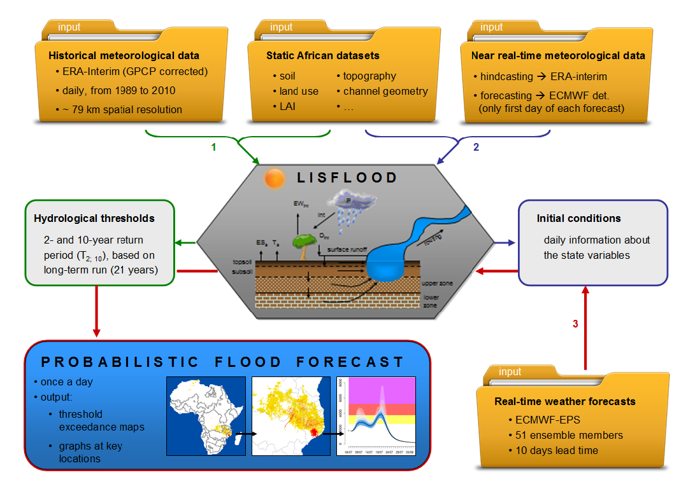
Figure X.7 Schematic overview of AFFS. Source: Thiemig et al. (2015).
Thiemig et al. (2015) investigates the predictive capability of AFFS was investigated in a hindcast mode to estimate its potential as an operational flood forecasting system for the whole of Africa. They showed that AFFS has a good potential to predict largescale and long duration flood events several days in advance. However, it should be noted that the performance of AFFS in an operational mode might be different due to the meteorological input data used for the calculation of the initial conditions which are different during hindcasting and operational forecasting. The limitations of AFFS centre around the detection of flood events with short durations (<week) and/or small affected areas (≤10 000 km2). The difficulties in detecting relatively small and/or short duration flood events is most likely due to the combination of (a) the limited precision given by the meteorological input data to capture small-scale meteorological events accurately in the correct time and place, and (b) the relatively coarse grid size of 0.1 x 0.1 ° that AFFS is operating on, which might be too coarse for these type of floods.
Applications: The AFFS’ ability to predict small-scale, short flood events was found to be limited.
User’s assistance: -
Additional information: The study by Thiemig et al. (2015) only evaluated the technical feasibility of AFFS, while issues related to practical implications, such as potential implementing institutes, funding and availability of technical expertise, were beyond the remit of the study. Overall, their study indicates that AFFS has a large potential to contribute to the reduction of flood-related losses in Africa by providing national and international aid organizations with timely medium-range flood forecast information. The HEPEX initiative (www.hepex.org) and the recently launched Global Flood Partnership (http://portal.gdacs.org/Global-Flood-Partnership) will be explored as a possibility for further testing of AFFS in research and in the experimental real-time mode.
Documentation (i.e. user’s manual, quick start guide): -
References:
- http://www.afronline.org/?p=38234
- http://www.scidev.net/sub-saharan-africa/disasters/analysis-blog/africa-analysis-the-need-for-flood-forecasting-system.html
- Thiemig, V., Bisselink, B., Pappenberger, F., & Thielen, J. (2015). A pan-African medium-range ensemble flood forecast system. Hydrology and Earth System Sciences, 19(8), 3365-3385. DOI: 10.5194/hess-19-3365-2015. https://www.hydrol-earth-syst-sci.net/19/3365/2015/hess-19-3365-2015.html
- Thiemig, Vera (2014). The development of pan-African food forecasting and the exploration of satellite-based precipitation estimates. PhD Dissertation, Supervisor(s): de Jong, Steven; de Roo, Ad. Utrecht University. https://www.narcis.nl/publication/RecordID/oai%3Adspace.library.uu.nl%3A1874%2F301673/uquery/African%20flood%20forecasting%20system/id/1/Language/NL

NOTE :
Roy, T., Serrat-Capdevila, A., Valdes, J., Durcik, M., & Gupta, H. (2017, August). Design and implementation of an operational multimodel multiproduct real-time probabilistic streamflow forecasting platform. Journal of Hydroinformatics, DOI: 10.2166/hydro.2017.111. Available Online 24 August 2017, http://jh.iwaponline.com/content/early/2017/08/24/hydro.2017.111
The task of real-time streamflow monitoring and forecasting is particularly challenging for ungauged or sparsely gauged river basins, and largely relies upon satellite-based estimates of precipitation. We present the design and implementation of a state-of-the-art real-time streamflow monitoring and forecasting platform that integrates information provided by cutting-edge satellite precipitation products (SPPs), numerical precipitation forecasts, and multiple hydrologic models, to generate probabilistic streamflow forecasts that have an effective lead time of 9 days. The modular design of the platform enables adding/removing any model/product as may be appropriate. The SPPs are bias-corrected in real-time, and the model generated streamflow forecasts are further bias-corrected and merged, to produce probabilistic forecasts that are computed via several model averaging techniques. The platform is currently operational in multiple river basins in Africa, and can also be adapted to any new basin by incorporating some basin-specific changes and recalibration of the hydrologic models.
  - GLOFAS (Global Flood Awareness System)
The Global Flood Awareness System (GloFAS) was developed by the European Commission and the European Centre for Medium-Range Weather Forecasts (ECMWF) to provide flood forecasts up to 1 month ahead on a global scale, providing a comprehensive overview on upcoming floods in large world river basins. GloFAS is independent of administrative and political boundaries. It couples state-of-the art weather forecasts with a hydrological model and with its continental scale set-up it provides downstream countries with information on upstream river conditions as well as continental and global overviews. The system has been set up following similar structure as in EFAS. GloFAS is still in research phase and is producing daily forecasts only in a pre-operational mode.
Website: http://globalfloods.jrc.ec.europa.eu/
Developers: EC Joint Research Centre (EC JRC) and European Centre for Medium-Range Weather Forecasts (ECMWF)
Download: Not applicable
Registration required: Yes
Contact: info@globalfloods.eu
Technical features: GloFAS has been producing probabilistic flood forecasts in a pre-operational environment since 2011; this environment enables continuous research, development, and testing in order to produce an operational tool that is independent of administrative and political boundaries. GloFAS can provide downstream countries with early warnings and information on upstream river conditions alongside global overviews of upcoming flood events in large river basins for decision makers ranging from water authorities and hydropower companies to civil protection and international humanitarian aid organizations. The main functionalities of GloFAS are three fold:
- Display of meteorological information: Accumulated precipitation for deterministic forecasts & Probabilities of rainfall exceedance for ensemble forecasts
- Flood early detection up to 30 days in advance (depending on the river basin size:) Visualisation of hydrographs at specific locations & Comparison with flood return periods derived from the climatology
- Added value information for flood forecast: Visualization of forecast persistence & Probabilities to exceed a specific flood return period (as derived from the model climatology)
Daily forecasts The ECMWF Ensemble Prediction System (ENS) is the operational ensemble forecasting product of the ECMWF and consists of 51- member ensemble global forecasts. The weather forecast component has a horizontal grid resolution of about 32 km for 10 days, increasing to 65 km from day 11 to 15. In the GloFAS system, ENS weather forecasts of the 00:00 UTC forecast are processed by the land surface module.
Reference climatology The ERA-Interim archive, a global atmospheric reanalysis produced by the ECMWF, contains gridded estimates of meteorological variables and surface parameters. It has horizontal resolution of about 80 km and covers the period from 1 January 1979 onwards. For the reference climatology used in GloFAS the ERA-Interim precipitation dataset has been bias-corrected using the Global Precipitation Climatology Project (GPCP).
HTESSEL HTESSEL is the land surface scheme used by ECMWF in its operational weather forecast system. HTESSEL computes the land surface response to atmospheric forcing, and estimates the surface water and energy fluxes and the temporal evolution of soil temperature, moisture content and snowpack conditions. Operational ensemble forecasts of surface and sub-surface runoff (soil to groundwater percolation) are extracted from the daily output of the ECMWF forecasts and then resampled to 0.1° resolution to be used as input by the river routing model. Further, an offline simulation of HTESSEL forced by ERA-Interim near-surface fields and bias-corrected ERA-Interim precipitation was performed to derive a 21 yr climatology starting in 1990, including surface and sub-surface.
LISFLOOD global LISFLOOD is a GIS-based spatially distributed hydrological model, which includes a one-dimensional channel routing model. The LISFLOOD model is currently running within the European Flood Awareness System (EFAS) on an operational basis covering the whole of Europe on a 5 km grid. In the context of global flood modelling, the transformation from precipitation to surface and sub-surface runoff is done by HTESSEL. For routing, LISFLOOD global is set up to simulate the groundwater and routing processes. Surface runoff is routed via overland flow to the outlet of each cell. Subsurface storage and transport are modelled using two linear reservoirs.
The GloFAS system is composed of an integrated hydro-meteorological forecasting chain and of a monitoring system that analyses daily results and shows forecast flood events on a dedicated web platform. Figure X. 8 shows the components available on GloFAS and the workflow.
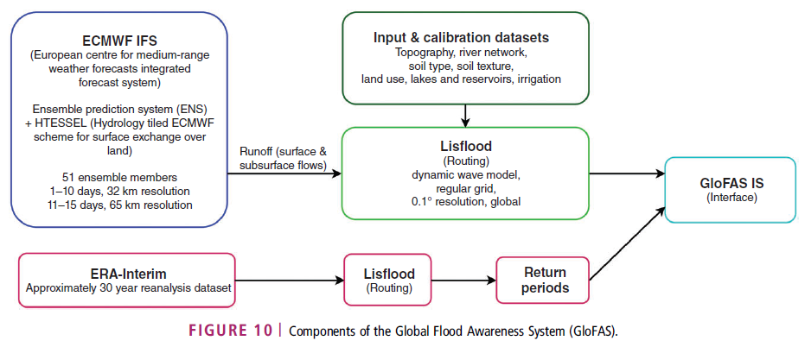
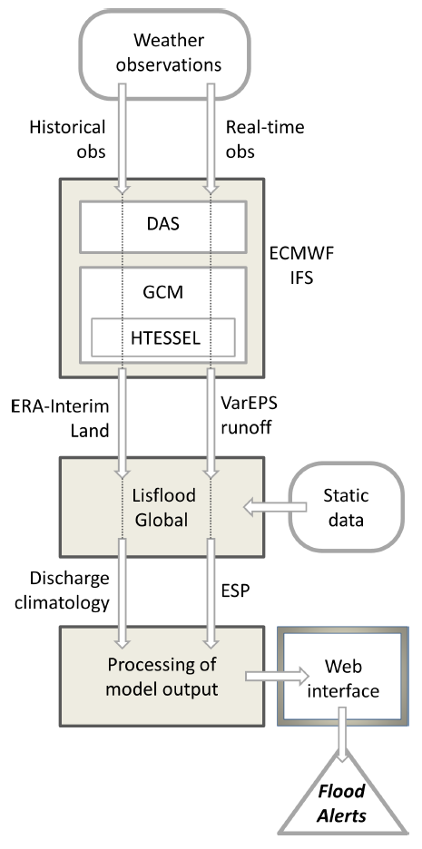
Figure X.8 Components of GloFAS and the overview schematic of theworkflow. Source: Emmerton et al. (2016) and http://globalfloods.jrc.ec.europa.eu/user-information/data-and-methods, respectively.
Ensemble streamflow predictions (ESPs) are run operationally on global scale by feeding surface and subsurface runoff into the LISFLOOD hydrological model. Although the precipitation input spans 15 days, hydrological simulations are computed for a 45-day time horizon, to account for the delayed routing of flood waves in large river basins, with time of concentration of the order of one month. From day 16 to day 45, input maps of surface and subsurface runoff are set to zero; therefore, the hydrological model will simply convey towards the outlet water already within each river basin.
- Initial condition maps to start up the model are first taken from the last available day of ERA-Interim dataset
- Initial conditions for subsequent simulations are then extracted from the results of the model run with the ENS control run, after the first day of simulation
- Resulting ESP maps for each daily time step and ensemble member are compared with reference threshold maps derived from the streamflow climatology, corresponding to return periods of 2, 5 and 20 yr
- Summary threshold exceedance maps are calculated accordingly, which show the maximum probability of exceeding the 5 and 20 yr return period within the forecast horizon
The map viewer is a web-mapping platform which provides an easy access to the flood forecasts of the Global Flood Awareness System (GloFAS). The products are tailored to give a fast overview of the hydro-meteorological situation, ongoing and upcoming flood events.
- Flood early detection up to 30 days in advance: Forecasting simulations are run every day using the latest ECMWF Ensemble Prediction System (ENS) and a cascade of hydrological models. This results in 51 possible ensemble streamflow predictions for the selected forecast horizon (i.e., 30 days in the current setting). For reporting points, the ensemble streamflow predictions (ESP) time series are plotted versus the forecast horizon.
- Accumulated rainfall: In order to provide a fast overview of the precipitation forecast, 4 maps of accumulated rainfall are produced. (i) Probability of exceeding 50/150/300 mm of accumulated rainfall over the forecast range of 10 days for the ensemble ECMWF forecast (ii) Amount of accumulated rainfall over the forecast range of 10 days for the median of the ensemble ECMWF forecast
- Threshold exceedance maps and Reporting points: Summary threshold exceedance maps are showing the maximum probability of exceeding the 5 and 20 year return period thresholds within the forecast horizon. Reporting points are chosen in the river network where a high flood probability is detected. There are three classifications: yellow (assigned to points with ESP mean between 2 and 5 year return period), red (assigned to points with ESP mean between 5 and 20 year return period) and purple (assigned to points with ESP mean above 20 year return period).
- Predictions time series and persistence diagrams: At each point, Ensemble streamflow predictions (ESP) time series are plotted versus the forecast horizon, together with persistence diagrams showing the probability of exceeding the three return period thresholds (2/5/20 year return periods) for each day of simulation and the evolution over the latest consecutive forecasts.
Applications: As of the September 14, 2015, GloFAS has 177 registered users from governmental or other public authorities (~28%), non-governmental organizations (NGOs, ~7%), the private sector (~10%), and from academic/training and/or research institutions (~55%). As with EFAS, GloFAS is used by national services to provide additional early flood information and is used by, for example, civil protection and humanitarian aid organizations who benefit from a global overview of flood events and may have no other source of information for the region of interest. GloFAS is also used by the ERCC for the purpose of compiling reports on natural hazards and flood risk across the globe.
GloFAS users include national and regional water authorities, hydropower companies, water resource managers, civil protection and first line responders, and international humanitarian aid organisations.
GloFAS produces daily flood forecasts in a pre-operational manner since June 2011. GloFAS has shown its potential during the floods in Pakistan in August 2013 or in Sudan in September 2013 In its test phase this global forecast system was able to predict floods up to two weeks in advance. EC JRC is planning to continue with further research and development, rigorous testing and adaptations of the system to create an operational tool.
User’s assistance: The GloFAS Community Learning Framework appoints a two-way practical solutions and learning focus whereby GloFAS forecasters and developers learn how to tailor forecasts and uncertainty information to local users and incorporate local information into the forecasting system, and local users learn how to interpret and use probabilistic early flood information. For more information on the project please contact the Director: Prof. Hannah Cloke, h.l.cloke@reading.ac.uk.
Additional information: The EFAS and its global equivalent (GloFAS) are nearly completely automated and are intended to serve global disaster relief organizations and the operational agencies of countries with transboundary basins and/or relatively underdeveloped medium-range river forecasting systems (Alfieri et al. 2013, as cited in Pagano et al., 2014).
Users can registering and access the Global Flood Awareness System (GloFAS) forecast viewer or the GloFAS web services (hereinafter the "GloFAS products"). Access to the GloFAS products is provided free of charge subject to registration. Registered users (the “GloFAS user”) are granted access the GloFAS products.
- GloFAS products are provided for information purposes only. This means they do not constitute in any way a flood warning for which only national/regional institutions are authorized within their region of responsibility.
- GloFAS products are research products. This means products will not be free from errors or omissions. In addition, changes to the products might occur frequently and without prior notice.
- Certain GloFAS products are provided under license from third parties, including but not limited to ECMWF weather forecasts, and are subject to copyright and other intellectual property rights owned by ECMWF and/or other third parties. Third-party rights may be subject to specific conditions imposed by respective right-holders. These conditions, which you agree to respect, may be displayed in the metadata of the concerning product.
The GloFAS Community Learning Framework was initiated by the University of Reading as part of a World Bank GFDRR / DFID Challenge Fund Project with input from ECMWF, the JRC and the Red Cross Red Crescent Climate Centre. Support was also provided by an Impact award by the UK's Natural Environment Research Council, the University of Reading Endowment Fund and the University of Reading's Walker Institute.
Documentation (i.e. user’s manual, quick start guide): -
References:
- http://globalfloods.jrc.ec.europa.eu/
- Cloke HL, Stephens E, Neumann J. (2016). Global Flood Awareness System Learning Framework Report. Learning activities, outcomes and key actions from the first GloFAS Community Workshop 4th – 6th May 2016, University of Reading. Available at: http://globalfloods.jrc.ec.europa.eu/static/downloads/community_learning/GloFASLearningFrameworkReport-Oct16-v4p1.pdf
- Alfieri, L., Burek, P., Dutra, E., Krzeminski, B., Muraro, D., Thielen, J., & Pappenberger, F. (2013). GloFAS-global ensemble streamflow forecasting and flood early warning. Hydrology and Earth System Sciences, 17(3), 1161. DOI: 10.5194/hess-17-1161-2013. https://www.hydrol-earth-syst-sci.net/17/1161/2013/

  - GFDS (Global Flood Detection System)
The Global Flood Detection System monitors floods worldwide using near-real time satellite data. The Joint Research Centre of the European Commission, in collaboration with the Dartmouth Flood Observatory (Colorado University), has developed and runs the Global Flood Detection System (GFDS), that is an operational flood monitoring system. GFDS provides maps, alerts, and the raw data for users ranging from emergency managers and public authorities to scientists and web developers.
Website: http://www.gdacs.org/flooddetection/
Developers: EC Joint Research Centre, Dartmouth Flood Observatory
Download:
Registration required:
Contact: tom.de-groeve@jrc.ec.europa.eu
Technical features: The Global Flood Detection System web application publishes the results of a new processing technique for remote sensing data that allows near real-time detection of flooded areas worldwide. A procedure chain was developed at the JRC to automatically acquire and process the remotely sensed data in real time on an operational basis. The remotely observed flood events are integrated into a Global Disaster Alert and Coordination System (GDACS) including the estimation of its humanitarian impact.
Surface water extent is observed using passive microwave remote sensing (AMSR-E and TRMM sensors). The surface water extent detection methodology using satellite-based microwave data is explained in Kugler and De Groeve (2007). All data are available as global raster maps. The brightness temperature measured by AMSR-E and TRMM sensors is normalized into a water signal (showing the amount of surface water in each pixel). For each pixel, anomalies in surface water are calculated by comparing the values to the normal surface water. When surface water increases significantly (anomalies with probability of less than 99.5%), the system flags it as a flood. The flood magnitude is defined as the number of standard deviations above the mean. Time series are calculated in more than 10000 monitoring areas, along with small scale flood maps and animations.
- Satellite observations are processed as soon as they are available at JRC. Lag times vary for different satellites from around 3 hours (AMSR2) to around 24 hours (GPM). GFDS has processed all data for TRMM, AMSR-E, AMSR2 and GPM, covering a time period from December 1997 to now.
- Observations are converted in raster products on a daily basis and with global coverage, effectively providing water surface metrics with daily frequency for any location in the world.
GFDS currently monitors around 10000 areas, defined in collaboration with partners. For these areas, the flood signal is further processed to generate time series, flood maps and flood animations.
Applications: The GFDS has been producing flood alerts since 2007, with progressively improved methods. Previous validation studies have shown that, on a global scale, the system can detect floods in some cases up to 10 days before the international media (which is the usual source for information on floods). However, Kugler and De Groeve (2007) showed that omission and commission errors are significant if single pixels are used as observation sites (Revilla-Romero ET AL., 2014).
Some of the data products are:
- Live data in Google Earth
  - Floods Live is a KML file that will load GDACS floods alerts, GFDS animations, TRMM flood potential data and today's flood warnings of selected met offices.
- GFDS animations of the last 7 days for Google Earth
  - Magnitude
  - Signal (M/C ratio)
- Download gridded data (for 2009)
  - Brightness temperature: http://www.gdacs.org/floodetection/floods/tif/AvgTiffs
  - Signal (M/C ratio): http://www.gdacs.org/flooddetection/floods/tif/AvgSignalTiffs
  - Magnitude: available on request
- Animations
  - Southern Africa: http://www.gdacs.org/flooddetection/floods/Movies/Angola
User’s assistance: -
Additional information: The GFDS is open for collaboration with water authorities and researchers. Access to the data, download of client software or setting up monitoring sites can be requested.
Documentation (i.e. user’s manual, quick start guide): -
References:
- http://www.gdacs.org/flooddetection/
- http://www.gdacs.org/flooddetection/overview.aspx
- http://www.gdacs.org/flooddetection/download.aspx
- https://ec.europa.eu/jrc/en/scientific-tool/global-flood-detection-system
- https://ec.europa.eu/jrc/en/publication/global-flood-detection-system-data-product-specifications?r=dnl
- http://www.copernicus.eu/news/global-flood-detection-system-data-products-specification
- Kugler, Z. and De Groeve, T. (2007). The Global Flood Detection System, JRC Scientific and Technical Reports EUR 23303 EN-2007. Office for Official Publications of the European Communities, Luxembourg. Available at: http://publications.jrc.ec.europa.eu/repository/bitstream/JRC44149/reqno_jrc44149_gfds%20%28final%292.pdf
- De Groeve, T. (2010). Flood monitoring and mapping using passive microwave remote sensing in Namibia. Geomatics, Natural Hazards and Risk, 1(1), 19-35. DOI: 10.1080/19475701003648085. http://www.tandfonline.com/doi/full/10.1080/19475701003648085
- Revilla-Romero, B., Thielen, J., Salamon, P., De Groeve, T., & Brakenridge, G. R. (2014). Evaluation of the satellite-based Global Flood Detection System for measuring river discharge: influence of local factors. Hydrology and Earth System Sciences, 18(11), 4467-4484. DOI: 10.5194/hess-18-4467-2014. https://www.hydrol-earth-syst-sci.net/18/4467/2014/

  - GLOFFIS (Global Flood Forecasting Information System)
The Global Flood Forecasting Information System (GLOFFIS) is a research-oriented multi-model operational flood forecasting system based on Delft-FEWS. GLOFFIS is one of three global systems run by Deltares in the Netherlands; also operational are a storm surge model, GLOSSIS, and a water scarcity system, GLOWASIS. These three systems belong to an open, experimental information and communications technology facility, IdLab (interactive data research laboratory), and are being used to test new ideas around interoperability, hydrological predictability, big data, and visualization (Emerton et al., 2016).
Website: http://globalfloodforecast.com/glossis/index.htm
Developers: Deltares, the Netherlands
Download: Yes (only a subset of the datasets)
Registration required: Not applicable
Contact: helpdeskdata@deltares.nl
Technical features: In GLOFFIS two hydrological models, namely, the W3RA and PCRGLOB-WB model, are run in ensemble mode using GEFS and ECMWF-EPS (latency 2 days). The models run operationally 2-4 times a day and provide forecasts for the upcoming 7-10 days on soil moisture, discharge, snow water equivalent, water level and surge. The models are forced with various meteorological data (e.g. wind, precipitation) which are also shown in the viewer.
Similar to the approaches taken by many of the continental-scale flood forecasting systems, GLOFFIS uses several meteorological inputs to drive the hydrological component of the system. The idea behind this is to validate, verify, and inter-compare real-time rainfall (alongside temperature and potential evaporation) products as they become available. The initial conditions are derived from historical forcings based on both the GFS and the ECMWF control forecast (also extracted from the TIGGE archives) and a combination of FEWSNET (Africa) and Climate Prediction Center (CPC) Unified Gauge-Based Analysis of Global Daily Precipitation, complimented by GFS temperature and potential evaporation. Each of the NWP inputs are fed into two hydrological models (with multiple initial conditions), PCR-GLOBWB and W3RA, which also incorporate the HBV-96 snow module, to account for snow processes.
The setup allows running user defined high resolution or other large scale hydrological models within the operational system/setup in parallel. The schematic overview of GLOFFIS can be seen in Figure X.11.
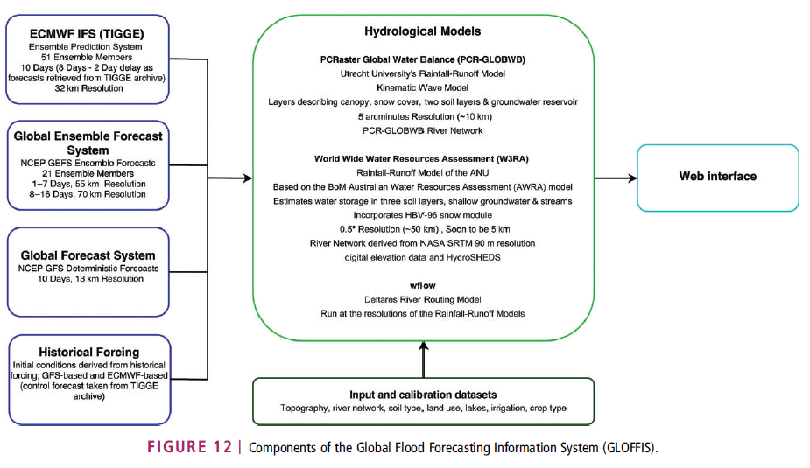
Figure X.11 Schematic overview of GLOFFIS. Source: Emmerton et al. (2016).
As the GLOFFIS and interoperability experiment is a very recent development, many aspects have yet to be implemented. The IdLab is also intended to investigate visualization and data exchange, and for GLOFFIS, multiple visualization and data access and exchange methods will be tested/validated. The two forthcoming visualization platforms for GLOFFIS are not yet available, but there is a plan to offer access via a platform similar to the system developed for Guanabara bay and via the Deltares adaguc portal, originally developed by KNMI. Forecast Verification Thorough statistical verification of GLOFFIS is underway using available open discharge and meteorological forecast data alongside (real-time) eyeball verification. Real-time discharge data is being collected and can be accessed and compared with the simulated discharge within the Delft-FEWS GLOFFIS platform and reports generated by the system. The verification threshold levels are derived from long historical discharge records and historical simulations, similar to the methods used in other continental- and global-scale forecasting systems.
The web viewer developed by Deltares, available at http://globalfloodforecast.com/glossis/index.htm, presents the results of the GLObal Flood Forecasting Information System (GLOFFIS) and the GLObal Storm Surge Information System (GLOSSIS) of Deltares. These forecasts can be used for early warning in those areas currently lacking any forecasting capability, or can provide boundary conditions for more refined local models.
A subset of the datasets are available for download these can be requested by sending an email to: helpdeskdata@deltares.nl Users can express in interest for other services, such as, but not limited to: (i) Higher resolution global results (ii) Scalar time series at certain locations (iii) Longer lead time forecasts (iv) Providing boundary conditions for regional models (v) More detailed regional models. info@deltares.nl.
Applications: GLOFFIS will be used for experiments into predictability of floods (and droughts) and their dependency on initial state estimation, meteorological forcing and the hydrologic model used.
The future activities include updating the resolution of the W3RA component to .05 (~5km) and implementation of an improved river network. Furthermore, the Japan Aerospace Exploration Agency (JAXA) Global Satellite Mapping of Precipitation (GSMaP) and the Global Precipitation Measurement (GPM) Integrated Multi-satellitE Retrievals for GPM (IMERG) products will also be added as additional datasets from which to derive initial conditions.
Although GLOFFIS is not yet fully implemented, it is being used internally at Deltares and by their customers, with discussions already underway between Deltares and other potential end users of the system. GLOFFIS is intended to be a research tool on predictability and interoperability first and foremost but will be suitable for a variety of applications once fully operational.
User’s assistance: GLOFFIS facilitates training for emergency and disaster management (along with hosting forecasting system user trainings in for instance the forecasting platform Delft-FEWS) both internally and externally.
Additional information: -
Documentation (i.e. user’s manual, quick start guide): -
References:
- EGU 2016 Abstract “Global scale predictability of floods” by Albrecht Weerts, Peter Gijsbers, and Frederiek Sperna Weiland. http://meetingorganizer.copernicus.org/EGU2016/EGU2016-15775-1.pdf
- Emerton, R. E., Stephens, E. M., Pappenberger, F., Pagano, T. C., Weerts, A. H., Wood, A. W., ... & Baugh, C. A. (2016). Continental and global scale flood forecasting systems. Wiley Interdisciplinary Reviews: Water, 3(3), 391-418. DOI: 10.1002/wat2.1137. http://onlinelibrary.wiley.com/doi/10.1002/wat2.1137/full

  - RASOR (Rapid Analysis and Spatialisation Of Risk)
The Rapid Analysis and Spatialisation Of Risk (RASOR) is a project funded by the European Union’s Seventh Framework Program for research, technological development and demonstration. The RASOR Consortium is an open partnership of concerned organizations, working together to improve risk management through an open source, freely available tool. The Consortium is inviting other interested organizations to partner as RASOR Associates and increase the availability of data and tools to manage risk.
Website: http://www.rasor-project.eu/
Developers:
Download:
Registration required: Yes
Contact:

Technical features: The Rapid Analysis and Spatialisation and Of Risk (RASOR) project has developed a platform to perform multi-hazard risk analysis to support the full cycle of disaster management, including targeted support to critical infrastructure monitoring and climate change impact assessment. RASOR uses the newly developed 12m resolution TanDEM-X Digital Elevation Model (DEM) for risk management applications. The DEM serves as a base layer, and is combined with other exposure, hazard and vulnerability data sets to develop specific disaster scenarios. RASOR overlays archived and near-real time very-high resolution optical and radar satellite data, combined with in-situ data for both global and local applications.
RASOR uses a scenario-driven query system to allow users to simulate future scenarios based on existing and assumed conditions, to compare with historical scenarios, and to model multi-hazard risk both before and during an event. Managers can, for example, determine the extent of flooding in a given area and assess risk to Critical Infrastructure Systems in terms of the residual functionality of a given system (e.g. energy, transport, health). Public authorities can determine the potential impact of sea surge scenarios based on actual, accurate subsidence and its effect on flood defence infrastructure. RASOR allows managers to use real scenarios when determining new mitigation or prevention measures, and integrate new, real-time data into their operational systems during response activities.
The schematic overview of RASOR is provided in Figure X.12.
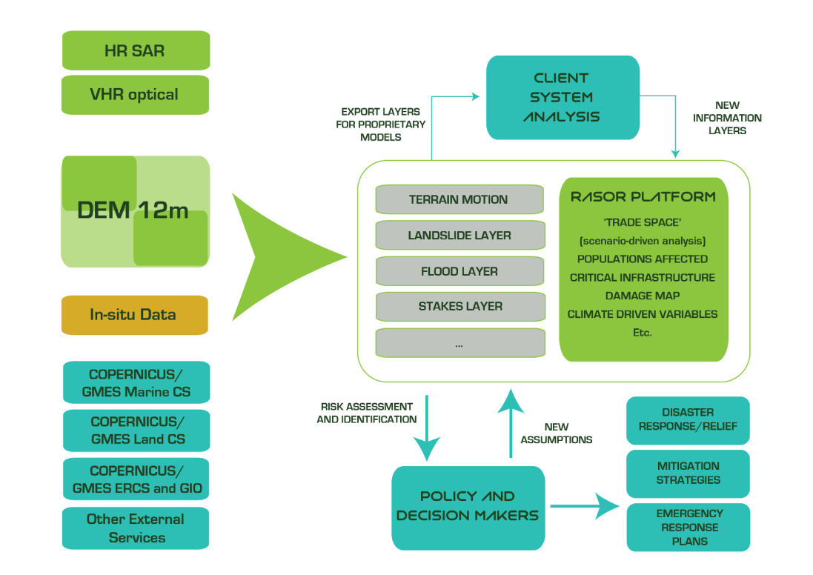
Figure X.12 Schematic overview of RASORGLOFFIS. Source: Emmerton et al. (2016).
The RASOR platform (http://www.rasor.eu/rasor/) has embedded models for hazard production for floods, tsunami, storm surges, earthquakes, hurricanes with easy-to-use interface that enables the user to change the fundamental inputs and parameters and produce a variety of “what-if” scenarios. The Platform accepts also pre-computed hazard layers that can be easily uploaded to through the platform on the RASOR Catalog. Hazard layers can be also derived from EO data starting as an example from flood delineation maps.
The RASOR Platform manages a wide typology of exposure layers that can describe buildings, facilities, lifelines, agricultural and environmental sites as well as population distribution at different special scale from object level to LU/LC type of information. A standard taxonomy based on an extension of the one proposed by the Global Earthquake Model is used. The platform assists the assets characterization. They are automatically mapped to the several libraries of vulnerability and fragility curves available in the platform when an impact computation is required.
The RASOR Platform can compute several types of impact depending on how well the exposure characterization is: Direct, Human, Social, Economic, Environmental, Functional impact. The Hazard, Exposure and Vulnerability layers produced or stored in the platform can be combined to produce impact indicators organized per type and target. A Report can be easily created to summarize the impact results in the report area of the platform.
The RASOR Platform enables analysis of historical events. A timeline of the available historical events that can be consulted is present in the platform that adjusts to the spatial domain explored. The platform allows the storage of observed or simulated data related to a specific event, that are presented in a organized way by the platform by clicking on the events timeline.
Applications: Initially, RASOR is available over five case study areas. The global tool will be available in 2016 for upload of user data sets and user risk assessment activities. Ultimately, the RASOR Consortium will offer global services to support in-depth risk assessment and full-cycle risk management.
After thirty months of development and improvements, the RASOR project was terminated at the Understanding Risk event organised by the World Bank in Venice on 16-20 May 2016. Applications of the RASOR platform are presented at a side event of the WMO 15th Commission of Hydrology, titled “National space programs in support of environmental and civil protection hydrological applications” organized by ISPRA, ASI and the Italian Civil Protection Department. RASOR showed the added value of EO data in assessing Hydro-meteorological disasters with the aid of a dedicated platform.
User’s assistance: -
Additional information: The RASOR Consortium offers three tracks of services based on adding value through customised exploitation of the RASOR tool for risk management and insurance markets: a global risk assessment service, and SME-led national and local services through innovative partnering arrangements in each national marketplace.
These tracks are validated in five different geographic locations (Haiti, Indonesia, Italy, Netherlands and Greece) with end users and practitioners, as well as with international organisations representing three different markets (World Bank for developing country and global analysis markets; UNOSAT for UN Agencies; Munich Re and RMS for insurance markets; and the European Commission’s agencies interested in risk management issues).
End users have been involved in conceiving the RASOR tool, and shape its ultimate outcome through the in-depth development of requirements, a User Workshop and a dedicated Service Validation activity and Service Level Agreements (SLA) that demonstrate the viability of a commercial RASOR service to be offered at the conclusion of the project.
The RASOR Community of Practice Inaugural Meeting was held on 17 May, 2016 in Mestre, Italy, bringing together about 50 people from user organizations and the RASOR partnership. The RASOR Community of Practice meeting was both the “Final Conference” showcasing the results of the RASOR FP7 project and the inaugural face-to-face meeting of a dynamic group of users and practitioners who will maintain the RASOR platform over the coming months and years, develop it and serve as a resource basin for RASOR-based analysis in the coming years.
The RASOR consortium is composed of 10 leading institutions from both the EO community, the DRR community and the ICT community: CIMA (Italy), AthenaGlobal (Greece), Acrotec, Sertit, Deltares (the Netherlands), EUCENTRE, DLR (Germanyy), INGV (Italy), NOA (Greece), Altamira. Supporting partners are CIMH (CARICOM), UWI (CARICOM), RCWC (Indonesia), DMEI (The Netherlands), Munich-Re (Germany), DPC (Italy), ARPA-SIMC (Italy), UNOSAT (IO), WB/GFDRR (IO), NASA (USA), ASI (Italy), RMS (UK), GEO Secretariat (IO), CEOS Disaster SBA Chair (IO), EARCS (Belgium), GEM (IO), UNISDR (IO).
Documentation (i.e. user’s manual, quick start guide): -
References:
- http://www.rasor-project.eu/project-description/
- Rossi, L., Koudogbo F. N., Duro J., Rudari R., & Eddy A. (2014). Multi-hazard risk analysis using the FP7 RASOR Platform. Proc. SPIE 9239, Remote Sensing for Agriculture, Ecosystems, and Hydrology XVI, 92390J (21 October 2014); DOI: 10.1117/12.2067444; http://dx.doi.org/10.1117/12.2067444
- Roberto Rudari and the RASOR Team. RASOR Project: Rapid Analysis and Spatialisation of Risk, from Hazard to Risk using EO data. Abstract presented at EGU 2015. http://meetingorganizer.copernicus.org/EGU2016/EGU2016-15073.pdf

DISASTER RESPONSE INITIATIVES

  - COPERNICUS EMS - MAPPING (Copernicus Emergency Management Services Mapping)
The Copernicus Emergency Management Service (Copernicus EMS) provides information for emergency response in relation to different types of disasters, including meteorological hazards, geophysical hazards, deliberate and accidental man-made disasters and other humanitarian disasters as well as prevention, preparedness, response and recovery activities. The EMS is funded by the European Commission and implemented through a variety of framework contracts. Three modules constitute the Copernicus EMS:
- Copernicus EMS - Mapping,
- European Flood Awareness System (EFAS, please refer to the next section),
- European Forest Fire Information System (EFFIS) and Global Wildfire Information System (GWIS).
Website: http://emergency.copernicus.eu/
Developers: EC Joint Research Centre
Download: Not applicable
Registration required: Free of charge only for Authorized Users
Contact: echo-mic@ec.europa.eu

Technical features: The Copernicus EMS Mapping consists of a set of mapping services funded by the European Commission. It addresses, with a worldwide coverage, a wide range of emergency situations resulting from natural or man-made disasters. The satellite imagery is used as a main data source about disasters. It covers in particular: floods, earthquakes, landslides, severe storms, fires, technological disasters, volcanic eruptions, humanitarian crises, tsunamis.
The Copernicus EMS Mapping provides all actors involved in the management of natural disasters with timely and accurate geospatial information derived from satellite remote sensing and completed by available in situ or open data sources. Copernicus EMS - Mapping is provided during all phases of the emergency management cycle, in two temporal modes, and free of charge for the users. It can be activated only by authorised users.
- Rapid Mapping consists of the on-demand and fast provision (within hours or days) of geospatial information in support of emergency management activities immediately following an emergency event. The products are standardised. A large set of parameters are available, and the user can choose among them when placing a service request. There are three categories of maps offered: Reference Maps, Delineation Maps (providing an assessment of the event extent) and Grading Maps (providing an assessment of the damage grade and its spatial distribution).
- Risk and Recovery Mapping consists of the on-demand provision of geospatial information in support of Emergency Management activities not related to immediate response. This applies in particular to activities dealing with prevention, preparedness, disaster risk reduction and recovery phases. There are three broad product categories: Reference Maps, Pre-disaster Situation Maps and Post-disaster Situation Maps.
Applications: Copernicus EMS can be used by entities and organisations at regional, national, European and international level active in the field of crisis management within the EU Member States, the Participating States in the European Civil Protection Mechanism, the Commission's Directorates-General (DGs) and EU Agencies, the European External Action Service (EEAS), as well as international Humanitarian Aid organisations.
User’s assistance: Not applicable.
Additional information: There are three distinct user categories:
- Authorised Users may trigger the service, by sending a Service Request Form (SRF) directly to the European Response Coordination Centre (ERCC). Authorised Users include National Focal Points (NFPs) in EU Member States and in countries participating in the European Civil Protection Mechanism as well as EC Services (DGs) and the Situation Room of the EEAS.
- Associated Users must coordinate with and go through the Authorised Users in order to trigger the service. Associated Users include local, regional and other public entities; International Governmental Organisations (e.g. UN agencies, World Bank), and National & International Non-Governmental Organisations; entities and institutions within the EEAS sphere such as EU Delegations, the INTCEN, the EU Satellite Centre.
- General Public Users are not authorised to trigger the service, but can be informed of an activation request through the web portal. Activations, for which sensitivity restrictions apply, are excluded.
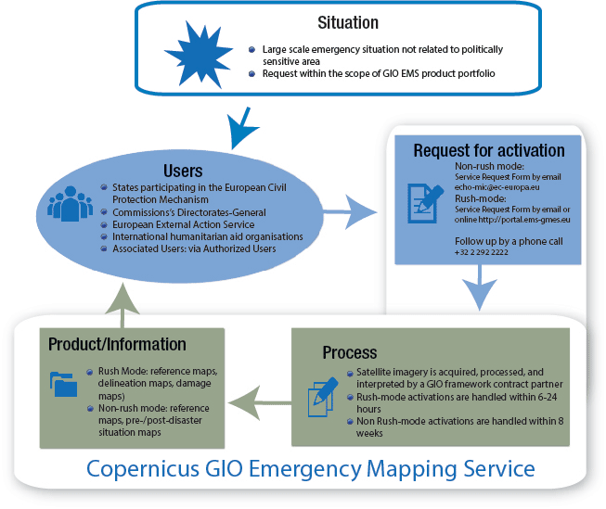
Figure X.5 Flowchart for the Copernicus EMS. Source: UN-SPIDER.
Products are available to the requesting Authorized User free of charge. The generation of is carried out by framework contract partners.
Copernicus EMS - Mapping Authorised Users may activate the service by completing the relevant Service Request Form (SRF) available in this link: http://emergency.copernicus.eu/mapping/ems/how-use-service. Associated Users have to contact their respective Focal Points who are authorised to trigger the service.
There are two activation modes: the Rush-Mode, for when the quick provision (within hours or days) of geospatial information in support of emergency management activities immediately following an event, is required. Conversely, the Non-rush Mode is activated when there is a need for the provision of geospatial information to support activities not relating to an immediate response. This mode is applicable during the prevention, preparedness, and recovery phases. Authorized Users trigger the mechanism by contacting the service directly, or via email (echo-mic@ec.europa.eu). Rush-mode activations can also be submitted through the website (http://emergency.copernicus.eu/). Every request must be followed up by a telephone call to the ERC/MIC (+32-2-292-2222).
Documentation (i.e. user’s manual, quick start guide): The Copernicus EMS User Guide consists of a package of several documents providing the users with all necessary information about the service. Among these are the Quick Start Guide and Product Portfolio. In the Product Portfolio, an overview of “Rapid Mapping” and “Risk & Recovery Mapping” products is presented along with their technical specifications. In addition, product examples are shown in relation to various disaster types.
References:
- http://emergency.copernicus.eu/
- http://www.copernicus.eu/main/emergency-management-user-guide
- http://www.un-spider.org/space-application/emergency-mechanisms/copernicus-gio-emergency-mapping-service
  - GDACS (Global Disaster Alert and Coordination System)
The Global Disaster Alert and Coordination System (GDACS) is a joint initiative of the United Nations Office for the Coordination of Humanitarian Affairs (OCHA) and the European Commission that serves to consolidate and improve the dissemination of disaster-related information, in order to improve the coordination of international relief efforts. It was established in 2004 and is a multi-hazard disaster monitor and alert system for earthquakes, tsunamis, floods, volcanoes, and tropical cyclones. GDACS provides real-time access to web-based disaster information systems and related coordination tools.
Website: http://www.gdacs.org/
Developers: UN OCHA and EC Joint Research Centre
Download: Not applicable
Registration required: Yes
Contact: gdacs@un.org
Technical features: The Global Disaster Alert and Coordination System (GDACS) was created as a cooperation framework between the United Nations and the European Commission in 2004, in order to address significant gaps in information collection and analysis in the early phase of major sudden-onset disasters.
The aim of GDACS is to provide the international disaster response community with a platform to ensure that disaster alerts and information relevant to the international disaster response is exchanged interactively in a structured and predictable manner among all concerned.
GDACS collects near real-time hazard information and combines this with demographic and socio-economic data to perform a mathematical analysis of the expected impact. This is based on the magnitude of the event and possible risk for the population. The result of this risk analysis is distributed by the GDACS website and alerts are sent via email, fax, and SMS to subscribers in the disaster relief community, and all other persons that are interested in this information.
The integrated GDACS website offers the following disaster information systems and online coordination tools:
- GDACS Disaster Alerts, which are issued and disseminated to some 25,000 subscribers immediately following sudden-onset disasters. The automatic estimates and risk analysis – the basis of the alerts - are provided by the European Commission Joint Research Centre (JRC) and the Global Flood Observatory.
- The Virtual OSOCC – a password-restricted online platform for real-time information exchange and cooperation among all actors in the first phase of the disaster. Information updates from the affected country and international responders are moderated by a dedicated team. The Virtual OSOCC has some 19,000 registered users, and is managed by the United Nations Office for the Coordination of Humanitarian Affairs (OCHA).
- Maps and satellite imagery from various providers, including UNOSAT and MapAction, are shared on the Virtual OSOCC. The GDACS Satellite Mapping and Coordination System (SMCS) provides a communication and coordination platform where organisations may monitor and inform stakeholders of their completed, current and future mapping activities during emergencies. This service is facilitated by the United Nations Institute for Training and Research (UNITAR) Operational Satellite Applications Programme (UNOSAT).
- A Science Portal dedicated to several scientific communities with special interests and a number of Expert Working Groups; the Portal is managed by European Commission JRC.
Applications: Many governments and disaster response organisations have formalised the use of GDACS tools and services in their national disaster response plans, in particular its automatic alerts and impact estimations and the VirtualOSOCC.
GDACS information is openly accessible through the GDACS platform interfaces. It can be directly integrated into other web portals or websites through RSS feeds or other standard formats.
User’s assistance: -
Additional information: The GDACS is guided by a Steering Committee and holds annual stakeholder meetings to bring together disaster managers, scientists, GIS and web developers, as well as other experts, in order to define standards for information exchange and strategy for the future development of GDACS services. OCHA’s Activation and Coordination Support Unit (ACSU) serves as the GDACS Secretariat.
Documentation (i.e. user’s manual, quick start guide): The guidelines document available on the GDACS website provide up-to-date information on the tools and services, and explain how they can be used by disaster managers in emergencies. They complement existing guidance materials, including the International Search and Rescue Advisory Group (INSARAG) Guidelines, the United Nations Disaster Assessment and Coordination (UNDAC) Field Handbook, publications by the International Federation of Red Cross and Red Crescent Societies (IFRC), and Standard Operating Procedures from the European Community Mechanism for Civil Protection, International Humanitarian Partnership (IHP), and the Euro Atlantic Disaster Response Coordination Centre (EADRCC).
References:
- http://portal.gdacs.org/about
- GDACS Guidelines (2014). Available at: http://www.gdacs.org/Documents/GDACS%20Guidelines%202014_-_FINAL.PDF
- http://lunar.jrc.it/critech/Default.aspx?Tabid=58
- De Groeve, T., Vernaccini, L., Annunziato, A. (2006). Modelling disaster impact for the global disaster alert and coordination system. In: Proceedings of the 3rd International ISCRAM Conference, Newark, NJ, pp. 409–417. Available at: http://www.iscramlive.org/ISCRAM2006/ISCRAM2006Proceedingszip/PapersTuesday/S3_T2_4_DeGroeve_etal.pdf
- De Groeve, T., Kugler, Z., Robert Brakenridge, G. (2007). Near Real Time Flood Alerting for the Global Disaster Alert and Coordination System. In: Proceedings of the 4th International Conference for Information Systems for Crisis Response and Management (ISCRAM), Delft, the Netherlands, pp. 33–39. Available at: https://floodobservatory.colorado.edu/Publications/DeGroeveKuglerBrakenridge.pdf

DISCUSSION
The comparison of available flood forecasting and early warning systems based on their technical features and capabilities can be seen in the Microsoft Excel document “Table_PLATFORMS_2017-Sep-11.xlsx”. These features and capabilities, listed in Table 1, are identified based on the challenges that operating agencies face (Pagano et al., 2014) and the operational needs of developing countries (discussions with Giacomo Teruggi and Paul Pilon) as well as review of the relevant literature.
Table 1. Assessment checklist for comparison of flood forecasting platforms for End-to-End End Early Warning Systems
Software availability | Developed by | The name of the institution(s) who developed the platform/system
 | Open software | It can be downloaded free of cost. Please not that a platform/system can be an open software, but source code does not necessarily have to be available.
 | Open source | It indicates availability of source code. “Yes” means that the source code is available.
 | License requirement | “No” means that there is no need to sign a license agreement between the developer and the customer
 | Cost | Whether the platform/system is free of charge, limited access conditions, etc.
 | Operational platform (i.e. computer environment) | Windows and/or Linux, web-based, browser independent, etc.
 | Coding language | The language that the software is written.
 | Download | The link where the software can be downloaded.
Technical set up | Spatial extent | User-defined, national, continental, global, etc.
 | Grid resolution | Not applicable for user defined platforms/systems
Early warning system components (Hagget, 1998) | Detection
 | Forecasting
 | Dissemination and warning
 | Response
Data management and infrastructure | Interoperability of different databases (meteorological, hydrological, etc.)
 | Ability to integrate real-time data from hydrological and meteorological observation networks
 | Capability of the system to integrate multiple data sources
 | Input data processing for appropriate spatial and temporal scale
 | Quantification of uncertainty
 | Data quality control
 | Data assimilation and updating
Models | Weather forecast
 | Satellite observations
 | Radar
 | Meteorological model
 | Hydrological model
 | Hydraulic model
 | Groundwater model
 | Flexibility in the integration of models and data
Forecasting | Maximum lead time
 | Forecast range
 | Purpose | Short vs. long term, quantitative forecast vs. flood outlook, warning vs. management, stage vs. volume, depth vs. duration, gauge vs. area related
 | Type | Deterministic vs. probabilistic, or ensemble
 | Uncertainty analysis (predictive uncertainty estimation)
Early warning | Accurate and timely warning generation
 | Alert mechanism (responsibles, criteria, etc.)
Risk assessment | Exposure and vulnerability
 | Damage assessment
Information dissemination (Dissemination of prediction results through appropriate products to the warning process) | Visualization tools
 | Information communicated | Discharge (based on rating curves), travel time, magnitude and shape of flood wave, duration of flooding, recurrence period of the forecast, uncertainty of the forecast, etc. location, hazard type, expected onset and duration, severity, probability of exceeding fixed warning thresholds, potential damage, affected population, etc.
 | Tools for communication | Website, radio, TV, etc.
Performance and sustainability | 24/7/365 operation (Yes/No)
 | Performance monitoring and evaluation (i.e. using indicators)
 | Training opportunities
Maintenance  [EXPERT KNOWLEDGE IS REQUIRED] | Institutional and operational requirements (low / medium / high)
 | Professional capabilities (low / medium / high)
Cost  [EXPERT KNOWLEDGE IS REQUIRED] | Initial set-up (low / medium / high)
 | Maintenance (low / medium / high) | Staff wages, data provision, investment in the model including the updates, adaptation of hardware, professional training
 | Operation (low / medium / high) | Acquiring of observations to calibrate and feed the model, obtaining NWP products, obtaining QPE (in situ, satellite, radar data)

According to this table,

BIBLIOGRAPHY
Adams, T. E., & Pagano, T. C. (Eds.). (2016). Flood Forecasting: A Global Perspective. Academic Press. https://books.google.ch/books?id=ttyoBAAAQBAJ&dq=Flood+Forecasting:+A+Global+Perspective&source=gbs_navlinks_s
Alfieri, L., Salamon, P., Pappenberger, F., Wetterhall, F., & Thielen, J. (2012a). Operational early warning systems for water-related hazards in Europe. Environmental Science & Policy, 21, 35-49. DOI: 10.1016/j.envsci.2012.01.008. http://www.sciencedirect.com/science/article/pii/S1462901112000457
Alfieri, L., Thielen, J., & Pappenberger, F. (2012b). Ensemble hydro-meteorological simulation for flash flood early detection in southern Switzerland. Journal of hydrology, 424, 143-153. DOI: 10.1016/j.jhydrol.2011.12.038. http://www.sciencedirect.com/science/article/pii/S0022169411009425
Alfieri, L., Burek, P., Dutra, E., Krzeminski, B., Muraro, D., Thielen, J., & Pappenberger, F. (2013). GloFAS-global ensemble streamflow forecasting and flood early warning. Hydrology and Earth System Sciences, 17(3), 1161. DOI: 10.5194/hess-17-1161-2013. https://www.hydrol-earth-syst-sci.net/17/1161/2013/
Bartholmes, J. C., Thielen, J., Ramos, M. H., & Gentilini, S. (2009). The european flood alert system EFAS–Part 2: Statistical skill assessment of probabilistic and deterministic operational forecasts. Hydrology and Earth System Sciences, 13(2), 141-153. DOI: 10.5194/hess-13-141-2009. https://www.hydrol-earth-syst-sci.net/13/141/2009/hess-13-141-2009.html
Cloke, H. L., & Pappenberger, F. (2009). Ensemble flood forecasting: a review. Journal of Hydrology, 375(3), 613-626. DOI: 10.1016/j.jhydrol.2009.06.005. http://www.sciencedirect.com/science/article/pii/S0022169409003291
Cloke HL, Stephens E, Neumann J. (2016). Global Flood Awareness System Learning Framework Report. Learning activities, outcomes and key actions from the first GloFAS Community Workshop 4th – 6th May 2016, University of Reading. Available at: http://globalfloods.jrc.ec.europa.eu/static/downloads/community_learning/GloFASLearningFrameworkReport-Oct16-v4p1.pdf
Cools, J., Innocenti, D., & O’Brien, S. (2016). Lessons from flood early warning systems. Environmental Science & Policy, 58, 117-122. DOI: 10.1016/j.envsci.2016.01.006. http://www.sciencedirect.com/science/article/pii/S1462901116300065
De Groeve, T., Vernaccini, L., Annunziato, A. (2006). Modelling disaster impact for the global disaster alert and coordination system. In: Proceedings of the 3rd International ISCRAM Conference, Newark, NJ, pp. 409–417. Available at: http://www.iscramlive.org/ISCRAM2006/ISCRAM2006Proceedingszip/PapersTuesday/S3_T2_4_DeGroeve_etal.pdf
De Groeve, T., Kugler, Z., Robert Brakenridge, G. (2007). Near Real Time Flood Alerting for the Global Disaster Alert and Coordination System. In: Proceedings of the 4th International Conference for Information Systems for Crisis Response and Management (ISCRAM), Delft, the Netherlands, pp. 33–39. Available at: https://floodobservatory.colorado.edu/Publications/DeGroeveKuglerBrakenridge.pdf
De Groeve, T. (2010). Flood monitoring and mapping using passive microwave remote sensing in Namibia. Geomatics, Natural Hazards and Risk, 1(1), 19-35. DOI: 10.1080/19475701003648085. http://www.tandfonline.com/doi/full/10.1080/19475701003648085
Demeritt, D., Nobert, S., Cloke, H. L., & Pappenberger, F. (2013). The European Flood Alert System and the communication, perception, and use of ensemble predictions for operational flood risk management. Hydrological Processes, 27(1), 147-157. DOI: 10.1002/hyp.9419. http://onlinelibrary.wiley.com/doi/10.1002/hyp.9419/full
Douris, J. (2017). Multi-Hazard Early Warning Systems: A Checklist. Multi-Hazard Early Warning Conference 22 - 23 May 2017, Cancún, Mexico Available at: https://www.wmo.int/earlywarnings2017/content/outcome-documents
WMO & ISDR (2006). Developing Early Warning Systems: A Checklist. Third International Conference on Early Warning: From concept to action, 27-29 March 2006, Bonn, Germany. Available at: http://www.unisdr.org/2006/ppew/info-resources/ewc3/checklist/English.pdf
Emerton, R. E., Stephens, E. M., Pappenberger, F., Pagano, T. C., Weerts, A. H., Wood, A. W., ... & Baugh, C. A. (2016). Continental and global scale flood forecasting systems. Wiley Interdisciplinary Reviews: Water, 3(3), 391-418. DOI: 10.1002/wat2.1137. http://onlinelibrary.wiley.com/doi/10.1002/wat2.1137/full
Haggett, C. (1998). An integrated approach to flood forecasting and warning in England and Wales. Water and Environment Journal, 12(6), 425-432. http://onlinelibrary.wiley.com/doi/10.1111/j.1747-6593.1998.tb00211.x/full
Kugler, Z. and De Groeve, T. (2007). The Global Flood Detection System, JRC Scientific and Technical Reports EUR 23303 EN-2007. Office for Official Publications of the European Communities, Luxembourg. Available at: http://publications.jrc.ec.europa.eu/repository/bitstream/JRC44149/reqno_jrc44149_gfds%20%28final%292.pdf
Pagano, T. C., Wood, A. W., Ramos, M. H., Cloke, H. L., Pappenberger, F., Clark, M. P., ... & Verkade, J. S. (2014). Challenges of operational river forecasting. Journal of Hydrometeorology, 15(4), 1692-1707. DOI: 10.1175/JHM-D-13-0188.1. http://journals.ametsoc.org/doi/abs/10.1175/JHM-D-110.1175/JHM-D-13-0188.1-0188.1
Pappenberger, F., Thielen, J., & Del Medico, M. (2011). The impact of weather forecast improvements on large scale hydrology: analysing a decade of forecasts of the European Flood Alert System. Hydrological Processes, 25(7), 1091-1113. DOI : 10.1002/hyp.7772. http://onlinelibrary.wiley.com/doi/10.1002/hyp.7772/full
Pappenberger, F., Stephens, E., Thielen, J., Salamon, P., Demeritt, D., Andel, S. J., ... & Alfieri, L. (2013). Visualizing probabilistic flood forecast information: expert preferences and perceptions of best practice in uncertainty communication. Hydrological Processes, 27(1), 132-146. DOI: 10.1002/hyp.9253. http://onlinelibrary.wiley.com/doi/10.1002/hyp.9253/full
Parodi, A., Kranzlmueller, D., Clematis, A., Danovaro, E., Galizia, A., Garrote, L., ... & Siccardi, F. (2017). DRIHM (2US): an e-Science environment for hydro-meteorological research on high impact weather events. Bulletin of the American Meteorological Society, (2017, in press). DOI: 10.1175/BAMS-D-16-0279.1. http://journals.ametsoc.org/doi/abs/10.1175/BAMS-D-16-0279.1
Ramos, M. H., Bartholmes, J., & Thielen‐del Pozo, J. (2007). Development of decision support products based on ensemble forecasts in the European flood alert system. Atmospheric Science Letters, 8(4), 113-119. DOI : 10.1002/asl.161. http://onlinelibrary.wiley.com/doi/10.1002/asl.161/full
Revilla-Romero, B., Thielen, J., Salamon, P., De Groeve, T., & Brakenridge, G. R. (2014). Evaluation of the satellite-based Global Flood Detection System for measuring river discharge: influence of local factors. Hydrology and Earth System Sciences, 18(11), 4467-4484. DOI: 10.5194/hess-18-4467-2014. https://www.hydrol-earth-syst-sci.net/18/4467/2014/
Roo, A. D., Thielen, J., Salamon, P., Bogner, K., Nobert, S., Cloke, H., ... & Muraro, D. (2011). Quality control, validation and user feedback of the European Flood Alert System (EFAS). International Journal of Digital Earth, 4(sup1), 77-90. DOI: 10.1080/17538947.2010.510302. http://www.tandfonline.com/doi/abs/10.1080/17538947.2010.510302
Rossi, L., Koudogbo F. N., Duro J., Rudari R., & Eddy A. (2014). Multi-hazard risk analysis using the FP7 RASOR Platform. Proc. SPIE 9239, Remote Sensing for Agriculture, Ecosystems, and Hydrology XVI, 92390J (21 October 2014); DOI: 10.1117/12.2067444; http://dx.doi.org/10.1117/12.2067444
Roy, T., Serrat-Capdevila, A., Valdes, J., Durcik, M., & Gupta, H. (2017). Design and implementation of an operational multimodel multiproduct real-time probabilistic streamflow forecasting platform. Journal of Hydroinformatics, DOI: 10.2166/hydro.2017.111. Available Online 24 August 2017, http://jh.iwaponline.com/content/early/2017/08/24/hydro.2017.111
Smith et al. (2016). On the operational implementation of the European Flood Awareness System (EFAS). ECMWF Technical Memorandum No.778. Available at: https://www.ecmwf.int/sites/default/files/elibrary/2016/16337-operational-implementation-european-flood-awareness-system-efas.pdf
Thielen, J., Bartholmes, J., Ramos, M. H., & Roo, A. D. (2009). The European flood alert system–Part 1: concept and development. Hydrology and Earth System Sciences, 13(2), 125-140. DOI: 10.5194/hess-13-125-2009. https://www.hydrol-earth-syst-sci.net/13/125/2009/hess-13-125-2009.html
Thiemig, V., Bisselink, B., Pappenberger, F., & Thielen, J. (2015). A pan-African medium-range ensemble flood forecast system. Hydrology and Earth System Sciences, 19(8), 3365-3385. DOI: 10.5194/hess-19-3365-2015. https://www.hydrol-earth-syst-sci.net/19/3365/2015/hess-19-3365-2015.html
Thiemig, Vera (2014). The development of pan-African food forecasting and the exploration of satellite-based precipitation estimates. PhD Dissertation, Supervisor(s): de Jong, Steven; de Roo, Ad. Utrecht University. https://www.narcis.nl/publication/RecordID/oai%3Adspace.library.uu.nl%3A1874%2F301673/uquery/African%20flood%20forecasting%20system/id/1/Language/NL
Todini, E. (2017). Flood Forecasting and Decision Making in the new Millennium. Where are We?. Water Resources Management, 1-19. DOI: 10.1007/s11269-017-1693-7 https://link.springer.com/article/10.1007/s11269-017-1693-7
Werner, M., Cranston, M., Harrison, T., Whitfield, D., & Schellekens, J. (2009). Recent developments in operational flood forecasting in England, Wales and Scotland. Meteorological Applications, 16(1), 13-22. DOI: 10.1002/met.124. http://onlinelibrary.wiley.com/doi/10.1002/met.124/full
Werner, M., Schellekens, J., Gijsbers, P., van Dijk, M., van den Akker, O., & Heynert, K. (2013). The Delft-FEWS flow forecasting system. Environmental Modelling & Software, 40, 65-77. http://www.sciencedirect.com/science/article/pii/S1364815212002083

