CHy Task Team on Interoperable Models and Platforms (TT E2)

9th Teleconference, Thursday 17 January 2019, 8 am CEST

Agenda

No tentative agenda was circulated. The meeting focused exclusively on the review of actions identified during the previous teleconference. Discussion about the possibility to have a face-to-face meeting in the next future was also held.
Meeting Minutes

Participants
The following experts attended the teleconference: Yeshewateswa Hundecha, Hwirin Kim, Jeff Perkins, Etienne Le Pape
From WMO Secretariat: Paul Pilon, Giacomo Teruggi
Sends regrets: Roberto Silva Vara, Tania Gascon, William Scharffenberg
Paul Pilon moderated the teleconference.

- Review of actions identified during the previous teleconference
A review of the actions was performed, and it was decided to restart the numbering to make the meeting minutes shorter and more summarized. In the following only the decisions on the way forward are reported.
Please refer to the previous teleconferences minutes to better understand the discussion behind each action.

REMINDER: the working website link is http://www.floodmanagement.info/TT-E2/tt-e2.html

NEW ACTION 1: Yuri and Hwirin to continue discussion on hydrological forecast requirements for NWP.
FOLLOW UP: Narendra had a discussion with Yuri and Hwirin during AWG meeting. Yuri to lead the drafting and prepare with Hwirin and Narendra’s input. ToC prepared during AWG meeting, but no advancement in populating it (10 pages planned). Yuri leading the exercise, but no deadline fixed (besides 2020). Hwirin to finalize deadlines with Yuri and Narendra.

NEW ACTION 2: Jeff and Hwirin to incorporate Bill’s revision in their templates to standardize the format and share with reviewers. FOLLOW UP: Hwirin sent feedback in the last couple of days on the platform template. Jeff still to provide feedback, possibly by the end of the month, on: the hydraulic model template, platforms template (integrating Hwirin’s comments) and providing feedback to Hwirin’s reservoir template.
NEW ACTION 3: Reviewers to provide comments to Hwirin and Jeff on their master templates. Each template’s main author is to ensure consistency with Bill’s example. This is to be completed prior to the next videoconference

Template | Main author | Reviewer | Status
Hydrologic Model | Bill | Yeshewa | FINALIZED
Hydraulic Model | Jeff | Bill | TO BE REVIEWED
Reservoir model | Hwirin | Jeff | TO BE REVIEWED
Platforms | Jeff | Hwirin | TO BE REVIEWED

FOLLOW UP: revision of the Hydraulic model, reservoir model and platforms is still to be performed. See follow up on action 2 above. Jeff to follow up with Bill on comments on the hydrodynamic/hydraulic model. Jeff will also undertake a review of all templates for consistency among them.

NEW ACTION 4: Etienne to circulate his 5 templates (POM, Hydraulic 1D and 2D, Hydrological Global and Specialized) to all TT E2 members, possibly in the final template format (already available: the one on hydrological models by Bill)
FOLLOW UP: Etienne sent hydrological templates after the last telecon, but for the others, he is pending finalization of the other templates as per the table above. Still to be sent: POM (platform) and the hydraulic (1D and 2D), once the templates will be available. Secretariat to liaise with Etienne once action 3 has been finalized. As action 3 is still pending,

NEW ACTION 5: Secretariat to restructure the working website creating new categories (provisional titles):
-Master templates finalized (Bill’s)
-Master templates to be reviewed and finalized (all others)
-Filled in templates (Etienne’s hydrological models)
-Glossary
FOLLOW UP: Secretariat uploaded accordingly on the website. Secretariat to upload the latest version from Hwirin (received this morning Geneva time).

NEW ACTION 6: TT E1 was contacted for input on the definition of “urban flood” that had been develop by TT E2 with assistance of the Secretariat.
3-4 comments from TT E1 (Yuri, Marcelo and others) on the definitions have been provided to the Secretariat. Definition to hopefully be finalized during next TT E1 teleconference on November 22.
FOLLOW UP: Secretariat to retrieve outcomes of the ongoing discussion (from Yuri and Nakul) and keep the Task Team Members informed

NEW ACTION 7: Secretariat to inquire among HAs, OPACHEs, CHy members, AWG (and any other TT E1 member not already included in the previous categories) which platform, hydrological, hydraulic and reservoir models are being used in their country. TT E2 to review the draft email.
FOLLOW UP: Revised approach - The questions will be embedded in a wider questionnaire circulated by WMO to PRs and Has. Hwirin reminded that CHy-EXT session could be a good opportunity to retrieve this information.

NEW ACTION 8: Bill to send TT members the Reference Guide containing explanations of what is required in each field or item in the evaluation criteria.
FOLLOW UP: Bill received feedback from the TT E2 members and a good portion of the Reference Guide has been finalized. Jeff would like to provide feedback, and he will share it with the TT. Etienne will also have a look at the Reference Guide document. 4-6 revised definitions were sent by Bill on 25 December. Task Team to review the available material. Secretariat to clarify with Bill if the material sent on 25 December includes the Reference Guide. Once finalized, it is suggested to wrap up the document as a pdf form.

- Other Business
Next Face-to-Face meeting: this topic will also be covered in TT E1 next teleconference. Both TT E2 participants agreed on the need to have a face-to-face meeting to follow up on these activities. Possible dates would be in Spring 2019, between the CHy-Ext in February and next Congress General in June. DWAT International Symposium will be held before 15 May, so it would be preferable to be held towards the end of April in Geneva.
The timeline table included in annex 2 was revised.

- Next Call
Next call is proposed for Tuesday 19 February 2019 from 08:00-10:00. This is meant as an option, to be confirmed by Bill. Otherwise a doodle poll will be launched for the following week.

ANNEX – Workplan of TT E2
(from the final report of the meeting on Establishing a Community of Practice on Flood Forecasting (CoP FF) Meeting – section 5.3)

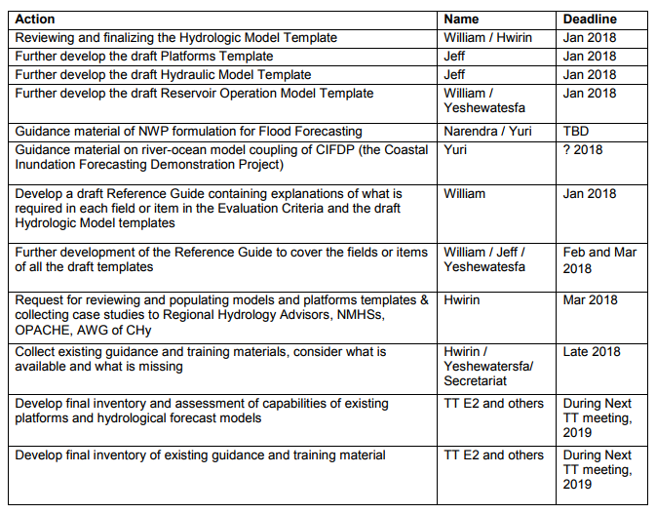
REVISED TABLE
# | Action | Name | Deadline
1 | Reviewing and finalizing the Hydrologic Model Template | Jeff and Yeshewa | Completed
2 | Finalize the Platforms Template | Jeff and Hwirin | End of February 2019
3 | Finalize the draft Hydraulic Model Template | Hwirin and Jeff | End of February 2019
4 | Finalize the draft Reservoir Operation Model Template | Jeff and Hwirin | End of February 2019
5 | Ensure consistency of all templates and highlight fields needing reference guide definitions | Jeff | End of February 2019

6 | Guidance material of NWP formulation for Flood Forecasting | Yuri, Hwirin and Narendra | Hwirin to provide date
7 | Guidance material on river-ocean model coupling of CIFDP (the Coastal Inundation Forecasting Demonstration Project) | Yuri | Check with Yuri
8 | Develop a draft Reference Guide containing explanations of what is required in each field or item in the Evaluation Criteria and the draft Hydrologic Model templates | Bill | Completed  (but to be checked)
9 | Further development of the Reference Guide to cover the fields or items of all the draft templates | Jeff and Hwirin | End of March 2019
10 | Request for reviewing and populating models and platforms templates to Regional Hydrology Advisors, NMHSs, OPACHE, AWG of CHy | Secretariat/ Hwirin | By 15 of May 2019
11 | Summarize and analyse the findings to develop a shortlist using CHy screening criteria. | Hwirin/Etienne/ Secretariat | End of May 2019
12 | Collect existing guidance and training materials, consider what is available and what is missing | Hwirin / Yeshewa/ Secretariat | End of June 2019
13 | Develop final inventory and assessment of capabilities of existing platforms and hydrological forecast models |  | August 2019
14 | Develop final inventory of existing guidance and training material |  | August 2019

