CHy Task Team on Interoperable Models and Platforms (TT E2)

10th Teleconference, Tuesday 19 February 2019, 8 am CEST

Agenda

No tentative agenda was circulated. The meeting focused exclusively on the review of actions identified during the previous teleconference.
Meeting Minutes

Participants
The following experts attended the teleconference: Yeshewateswa Hundecha, Hwirin Kim, Jeff Perkins, Etienne Le Pape
From WMO Secretariat: Paul Pilon, Giacomo Teruggi
Sends regrets: Roberto Silva Vara, Tania Gascon, William Scharffenberg
Paul Pilon moderated the teleconference.

- Review of actions identified during the previous teleconference
A review of the actions was performed, and it was decided to restart the numbering to make the meeting minutes shorter and more summarized. In the following only the decisions on the way forward are reported.
Please refer to the previous teleconferences minutes to better understand the discussion behind each action.

REMINDER: the working website link is http://www.floodmanagement.info/TT-E2/tt-e2.html

NEW ACTION 1: Yuri and Hwirin to continue discussion on hydrological forecast requirements for NWP. Narendra had a discussion with Yuri and Hwirin during AWG meeting. Yuri to lead the drafting and prepare with Hwirin and Narendra’s input. ToC prepared during AWG meeting, but no advancement in populating it (10 pages planned). Yuri leading the exercise, but no deadline fixed (besides 2020). Hwirin to finalize deadlines with Yuri and Narendra.
UPDATE: according to Yuri, following last AWG meeting in Geneva a ToC was developed with Narendra, specifying also the length of the chapters. No deadline was fixed, discussion to be held with the Secretariat to fix one.

NEW ACTION 2: Jeff and Hwirin to incorporate Bill’s revision in their templates to standardize the format and share with reviewers. Hwirin sent feedback in the last couple of days on the platform template. Jeff still to provide feedback, possibly by the end of the month, on: the hydraulic model template, platforms template (integrating Hwirin’s comments) and providing feedback to Hwirin’s reservoir template.
UPDATE: Jeff could not yet provide feedback due to the intense workload in Australia BoM. He will probably have to delegate to a colleague, who will contribute by end of February under Jeff’s supervision. Jeff to identify the colleague and share his details with the Secretariat.
NEW ACTION 3: Reviewers to provide comments to Hwirin and Jeff on their master templates. Each template’s main author is to ensure consistency with Bill’s example. This is to be completed prior to the next videoconference

Template | Main author | Reviewer | Status
Hydrologic Model | Bill | Yeshewa | FINALIZED
Hydraulic Model | Jeff | Bill | TO BE REVIEWED
Reservoir model | Hwirin | Jeff | TO BE REVIEWED
Platforms | Jeff | Hwirin | TO BE REVIEWED

FOLLOW UP: no feedback received by Jeff from Bill nor Hwirin. Feedback on Hwirin’s reservoir model will have to be delegated to Jeff’s replacement, whereas the Secretariat will be in charge of ensuring consistency among the different templates. This will be done once the final version of hydraulic and platform templates. Jeff shared with Secretariat a combined file with all the templates, which he used in September to check consistency among different templates. Secretariat to follow up with the latest versions of the templates and repeat a similar consistency-check exercise.

NEW ACTION 4: Etienne to circulate his 5 templates (POM, Hydraulic 1D and 2D, Hydrological Global and Specialized) to all TT E2 members, possibly in the final template format (already available: the one on hydrological models by Bill).
Etienne sent hydrological templates after the last telecon, but for the others, he is pending finalization of the other templates as per the table above. Still to be sent: POM (platform) and the hydraulic (1D and 2D), once the templates will be available.
UPDATE: As action 3 is still pending, Secretariat to liaise with Etienne once action 3 has been finalized.,

NEW ACTION 5: Secretariat updated the working website to include all latest available templates.
FOLLOW UP: Secretariat to upload latest version from Hwirin (received shortly after previous teleconference) and check if templates from Jeff (dated 28 September 2018) are the latest available.

NEW ACTION 6: Definition of Urban flooding. Discussions were held between Yuri, Nakul, Marcelo and TT E1.
UPDATE: TT E1 had a split decision, and will bring the issue to the CoP face to face meeting to find an agreement.

NEW ACTION 7: Secretariat was to inquire among HAs, OPACHEs, CHy members, AWG (and any other TT E1 member not already included in the previous categories) which platform, hydrological, hydraulic and reservoir models are being used in their country during CHy Ext.
FOLLOW UP: It was not possible to circulate the questions during CHy Ext, so the Secretariat will finalize the questions by end of current week and circulate them to the TT E2 members. Following this, a new approach to get the information will have to be sought.

NEW ACTION 8: Bill to send TT members the Reference Guide containing explanations of what is required in each field or item in the evaluation criteria. Bill received feedback from the TT E2 members and a good portion of the Reference Guide has been finalized. Jeff would like to provide feedback, and he will share it with the TT. Etienne will also have a look at the Reference Guide document. 4-6 revised definitions were sent by Bill on 25 December. Task Team to review the available material. Secretariat to clarify with Bill if the material sent on 25 December includes the Reference Guide. Once finalized, it is suggested to wrap up the document as a pdf form.
FOLLOW UP: Yeshewa went through the whole document and circulated comments yesterday. Jeff to add this task to the list of issues to be delegated to his colleague. The action is completed, see new action 9 below.

NEW ACTION 9: The Reference guide completed under action 8 is only applicable to the hydrological model template. Other reference guides with additional items related to the other templates will have to be developed by Hwirin and Jeff’s substitute by end of March.

- Other Business
Next Face-to-Face meeting: discussions are ongoing to have the next CoP face-to-face meeting being held in Seoul, Republic of Korea, during the last week of April (29 April – 3 May 2019). DWAT International Symposium will be held back to back, on the week of 7-10 May. All TT E2 members are invited to attend. A head count will be circulated by the Secretariat. The timeline table included in annex 2 was revised.

- Next Call
Next call is proposed for Friday 5 April 2019 from 08:00-10:00. This is meant as an option, to be confirmed by Bill and Jeff (and his substitute). Otherwise a doodle poll will be launched for the following week.

ANNEX – Workplan of TT E2
(from the final report of the meeting on Establishing a Community of Practice on Flood Forecasting (CoP FF) Meeting – section 5.3)

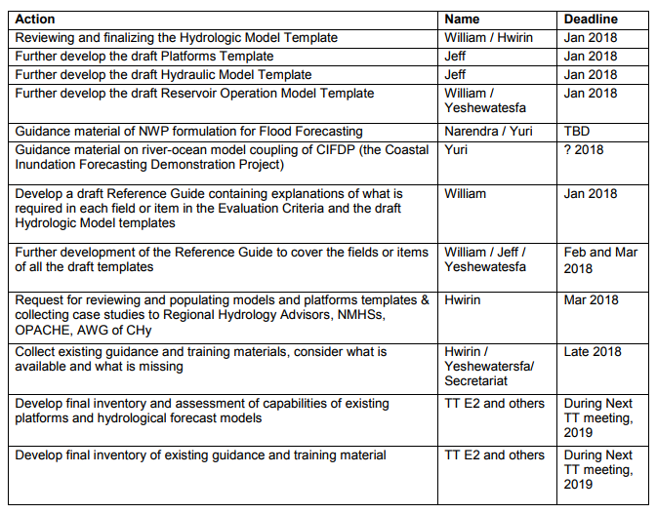
REVISED TABLE
# | Action | Name | Deadline
1 | Reviewing and finalizing the Hydrologic Model Template | Jeff and Yeshewa | Completed
2 | Finalize the Platforms Template | Hwirin (reviewer) and Jeff (lead terminator) | Hwirin to share comments on the latest version with Secretariat
3 | Finalize the draft Hydraulic Model Template | Bill (reviewer) and Jeff (lead terminator) | End of February 2019

4 | Finalize the draft Reservoir Operation Model Template | Jeff (reviewer) and Hwirin (lead terminator) | End of February 2019
5 | Ensure consistency of all templates and highlight fields needing reference guide definitions | Secretariat | End of February 2019
6 | Guidance material of NWP formulation for Flood Forecasting | Yuri, Hwirin and Narendra | Hwirin to provide date
7 | Guidance material on river-ocean model coupling of CIFDP (the Coastal Inundation Forecasting Demonstration Project) | Yuri | Secretariat to check with Yuri
8 | Develop a draft Reference Guide containing explanations of what is required in each field or item in the Evaluation Criteria and the draft Hydrologic Model templates | Bill | Completed
9 | Further development of the Reference Guide to cover the fields or items of all the draft templates | Jeff (substitute) and Hwirin | End of March 2019
9bis | Further development of the Reference Guide to provide an introduction | Bill and Hwirin | End of March 2019
10 | Request for reviewing and populating models and platforms templates to Regional Hydrology Advisors, NMHSs, OPACHE, AWG of CHy | Secretariat/ Hwirin | By 15 of May 2019
11 | Summarize and analyse the findings to develop a shortlist using CHy screening criteria. | Hwirin/Etienne/ Secretariat | End of May 2019
12 | Collect existing guidance and training materials, consider what is available and what is missing | Hwirin / Yeshewa/ Secretariat | End of June 2019
13 | Develop final inventory and assessment of capabilities of existing platforms and hydrological forecast models |  | August 2019
14 | Develop final inventory of existing guidance and training material |  | August 2019

